User Manual

Installation & Setup

Prerequisites

Python 3.8 or higher

pip package manager

Git (for cloning repository)

Installation Steps

Clone the repository:

git clone https://github.com/ferenimedez-stab/campusKubo-Boarding-Bedspace-Finder-for-Students.git

cd campusKubo-Boarding-Bedspace-Finder-for-Students

Create virtual environment:

python -m venv venv

Activate virtual environment:

Windows: venv\Scripts\activate

Mac: source venv/bin/activate

Install dependencies:

pip install -r requirements.txt

Set up environment variables (optional):

Create a .env file in the root directory:

SECRET_KEY=your-secret-key-here

GOOGLE_MAPS_API_KEY=your-google-maps-api-key

EMAIL_USERNAME=your-email@gmail.com

EMAIL_PASSWORD=your-app-password

Initialize database:

python -c "from app.storage.db import init_db; init_db()"

Running the Application

Desktop App Run

python app/main.py

Admin vs Regular User Capabilities

Administrator Capabilities

User Management

View all users (Tenants, Property Managers, Admins)

Approve/reject Property Manager registrations

Deactivate/reactivate user accounts

View user activity logs

Reset user passwords

Property Management

View all property listings

Approve/reject pending listings

Edit listing details

Remove inappropriate listings

View listing statistics

System Administration

View system analytics and reports

Configure system settings

Manage payment records

View reservation statistics

Generate reports

Dashboard Features

Real-time statistics (users, listings, reservations)

Recent activity feed

Revenue tracking

System health monitoring

Property Manager Capabilities

Property Management

Create and manage property listings

Upload property photos

Set pricing and availability

Edit listing details

View reservation requests

Reservation Management

Accept/reject reservation requests

View tenant information

Manage booking calendar

Process payments

Profile Management

Update profile information

Manage payment methods

View earnings and statistics

Dashboard Features

Property performance metrics

Reservation calendar

Recent bookings

Revenue tracking

Tenant Capabilities

Property Search

Browse available properties

Advanced search and filtering

View property details and photos

Check availability calendar

Reservation Management

Make reservation requests

View booking history

Cancel reservations (with restrictions)

Rate and review properties

Profile Management

Update personal information

Manage payment methods

View reservation history

Dashboard Features

Upcoming reservations

Booking history

Favorite properties

Recent searches

Screenshots
- Landing Page:

- Signup and Login Forms: Email/password fields, forgot password link, sign-up/log-in action.

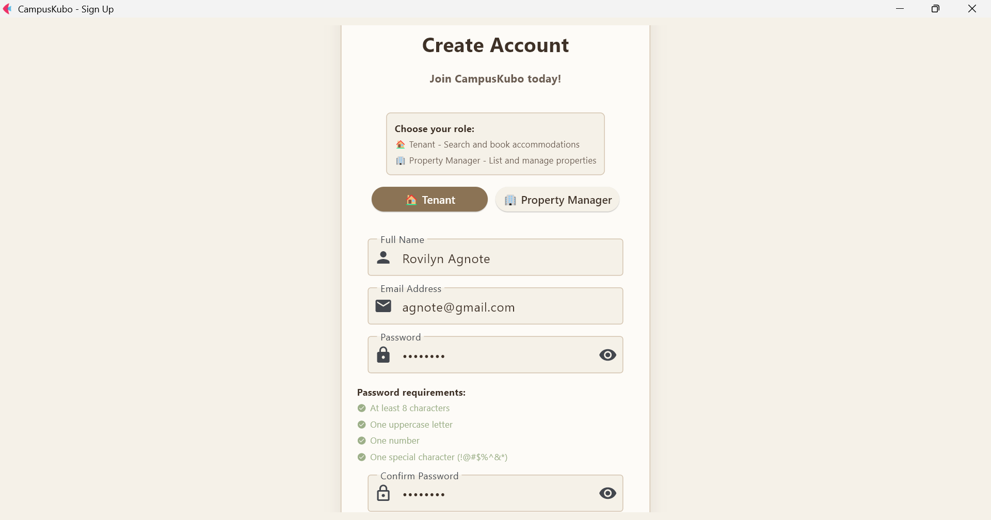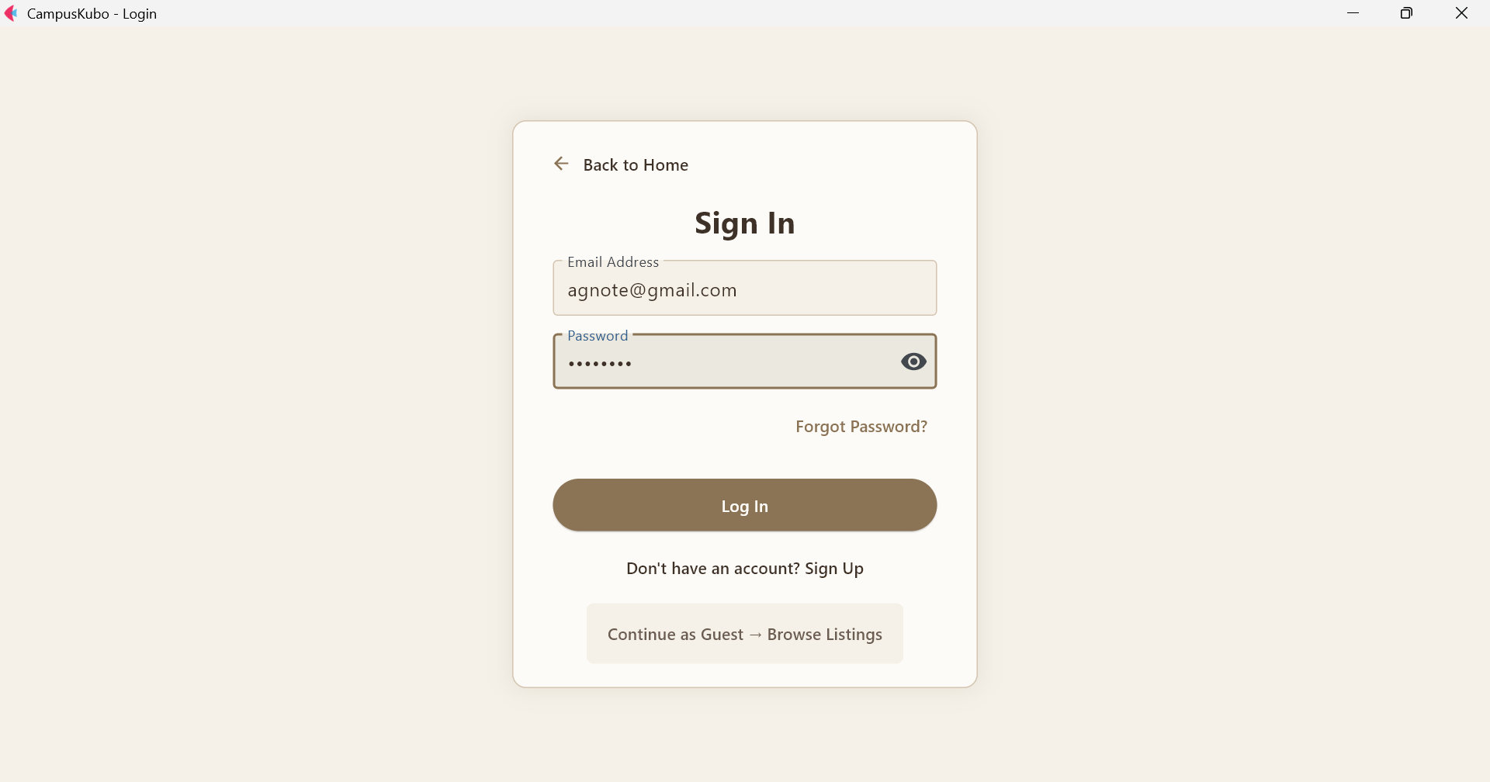

- Listings Pages (for browsing properties): Property listings with details, sign-up and log-in buttons, search filter sidebar

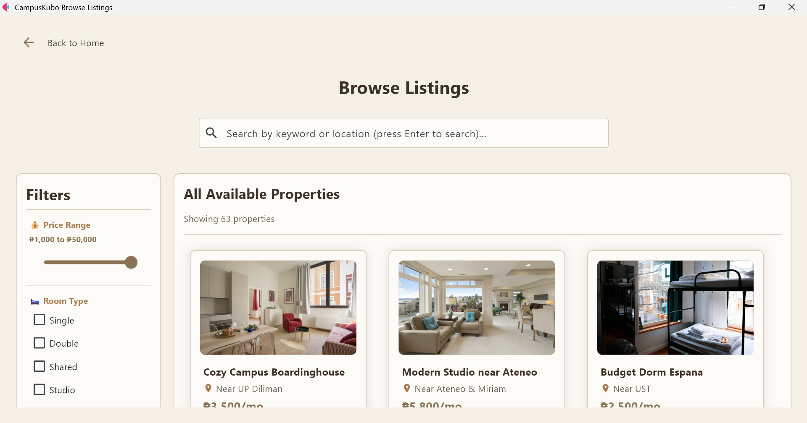
Shows search bar, and list of available properties.

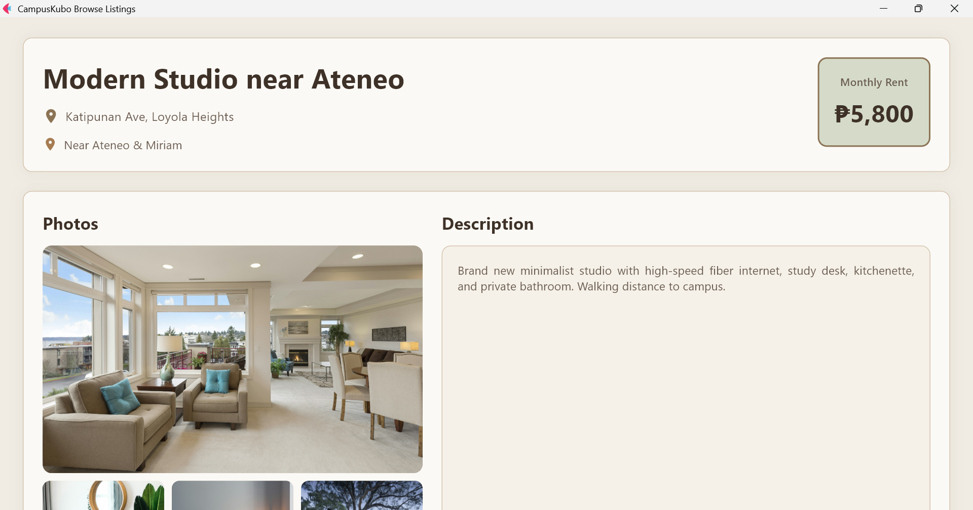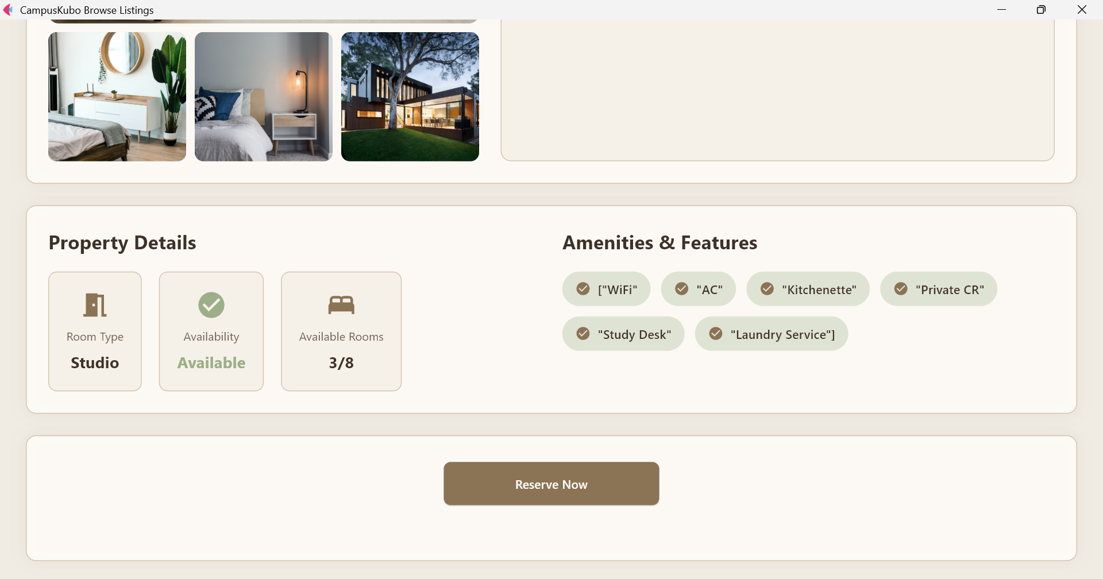
Displays full listing info with photos, location, price, and description.
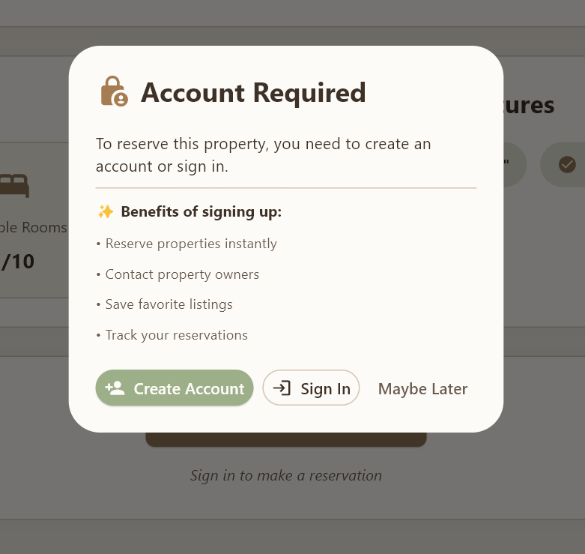
Prompts users to sign up or log in to reserve properties.

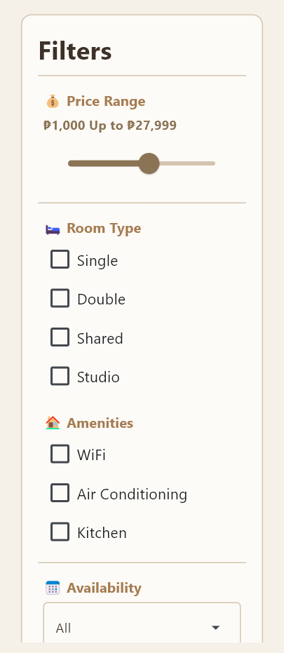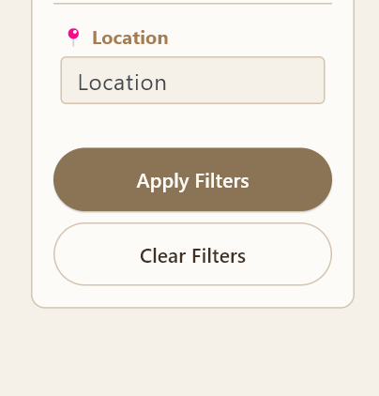
Lets users filter by price, room type, amenities, availability and locations.

- Admin Dashboard: Key metrics (users, active listings, reservations), quick actions.

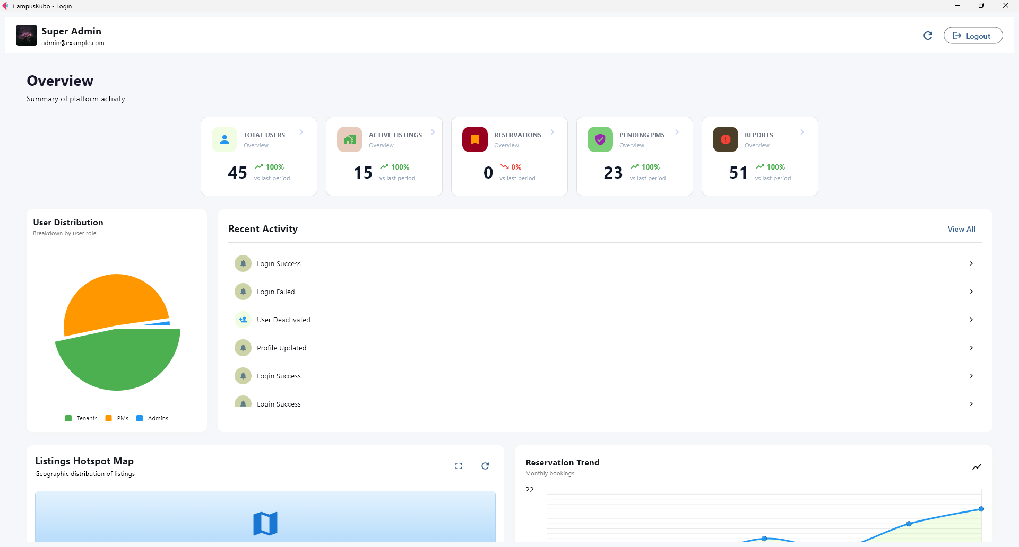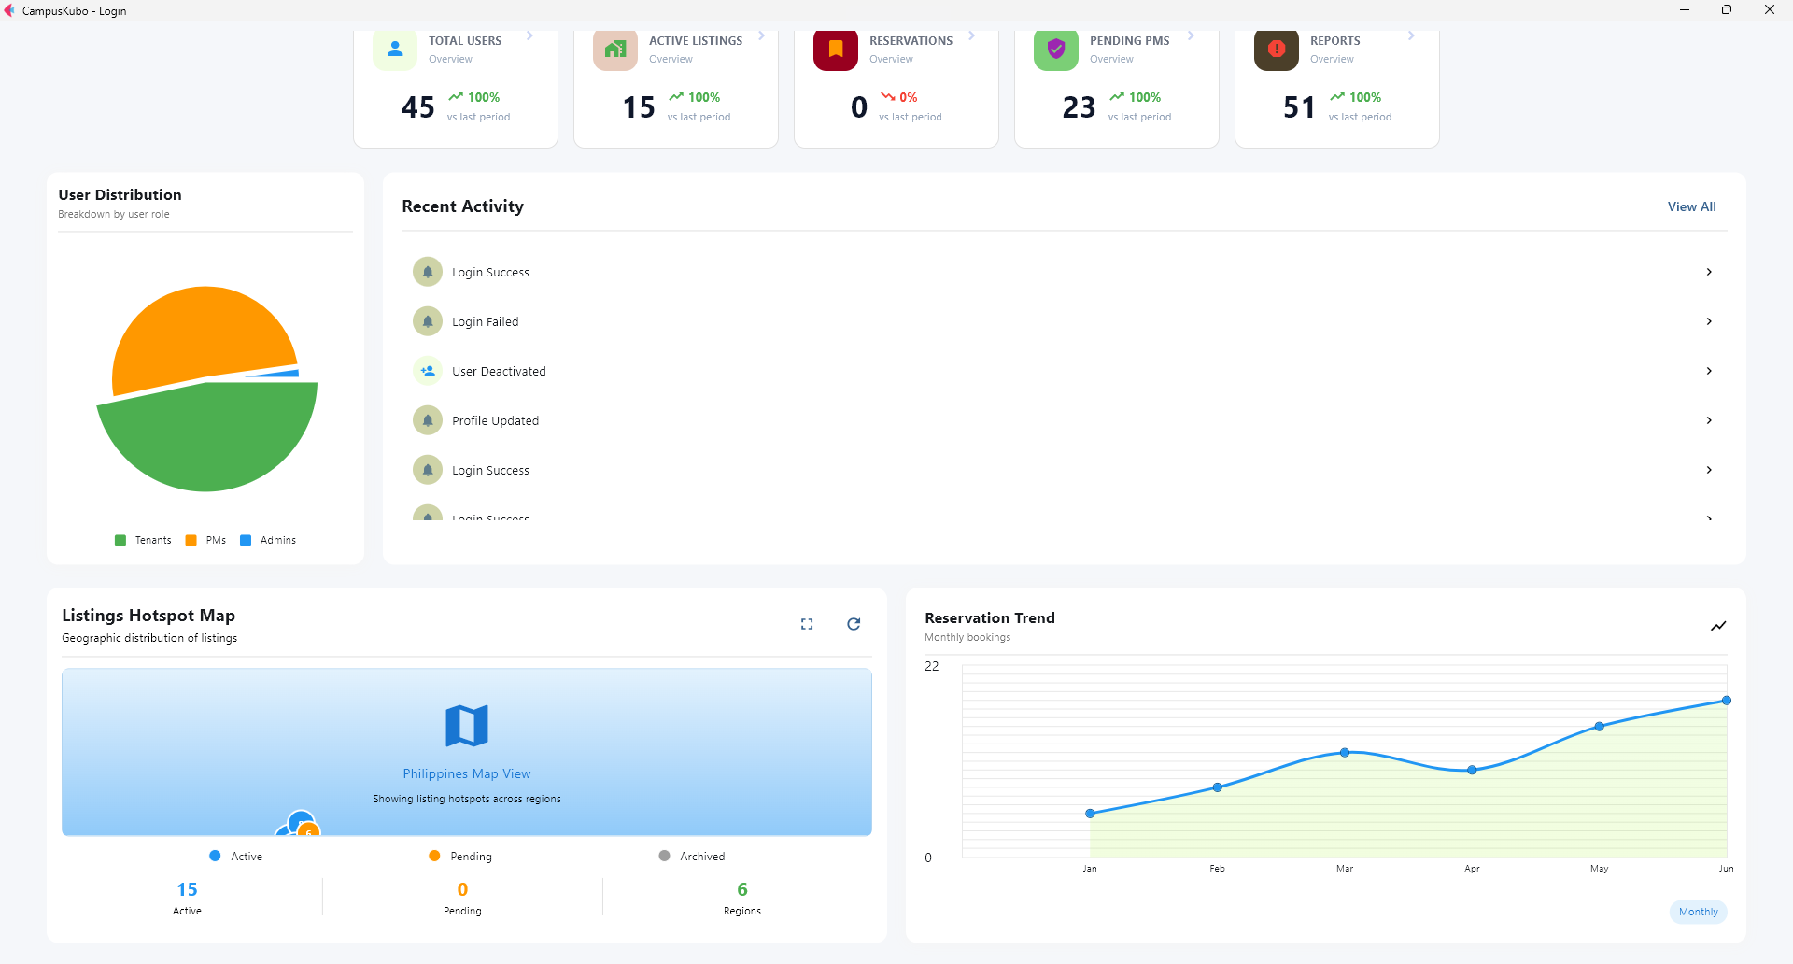
Main Dashboard View

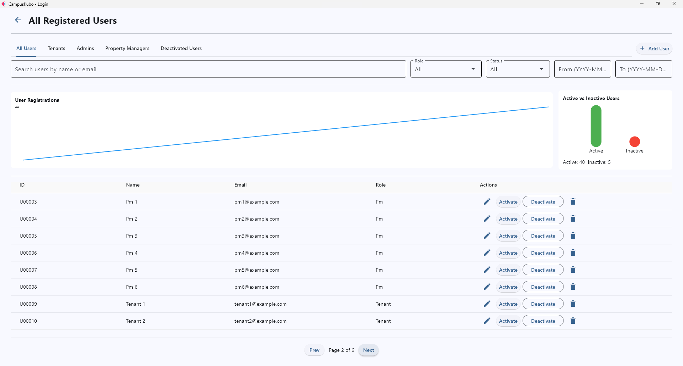
User Management Page
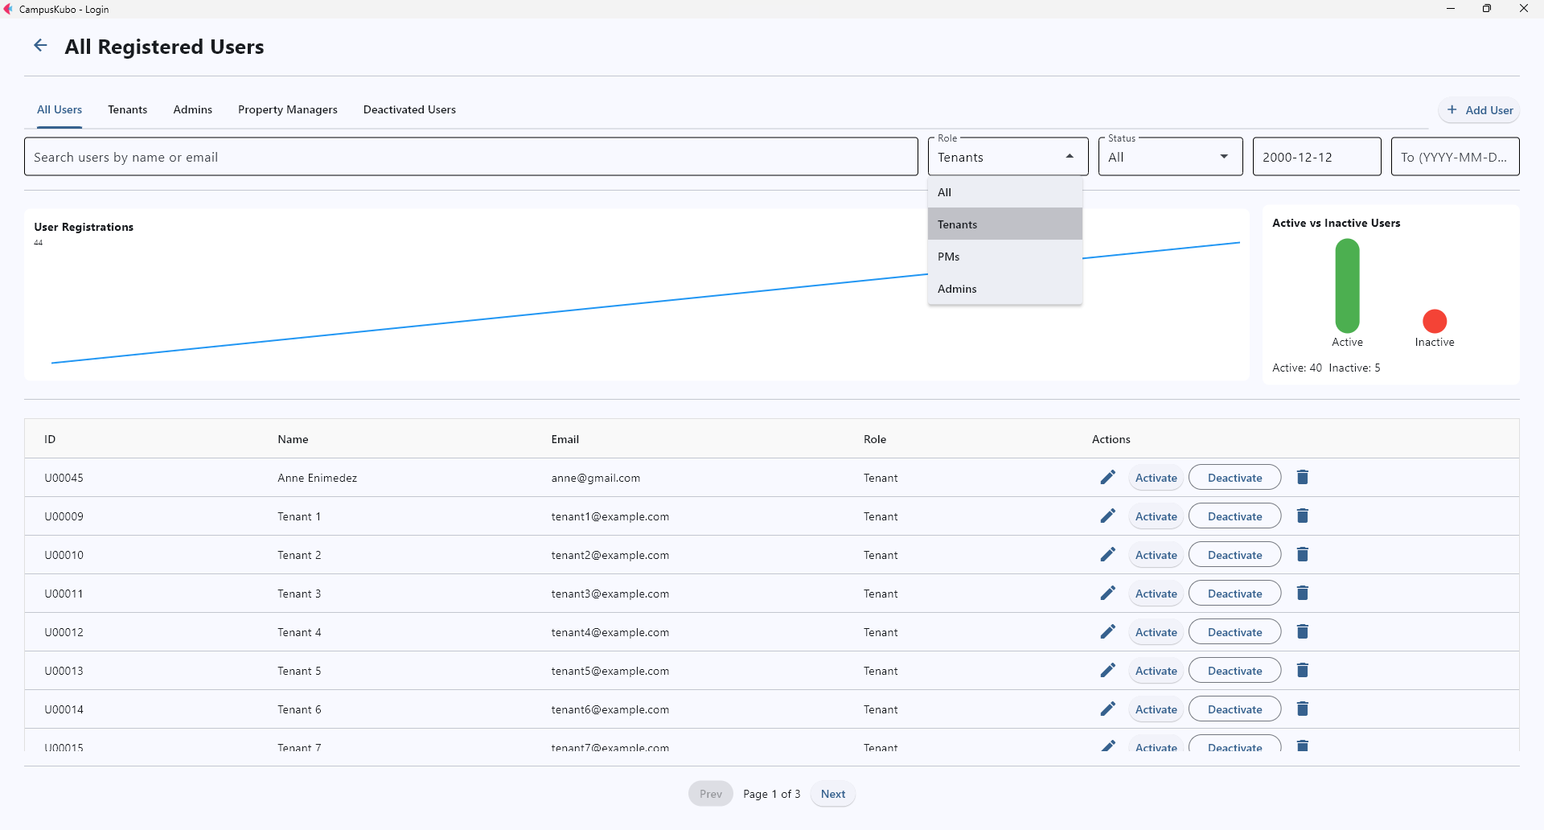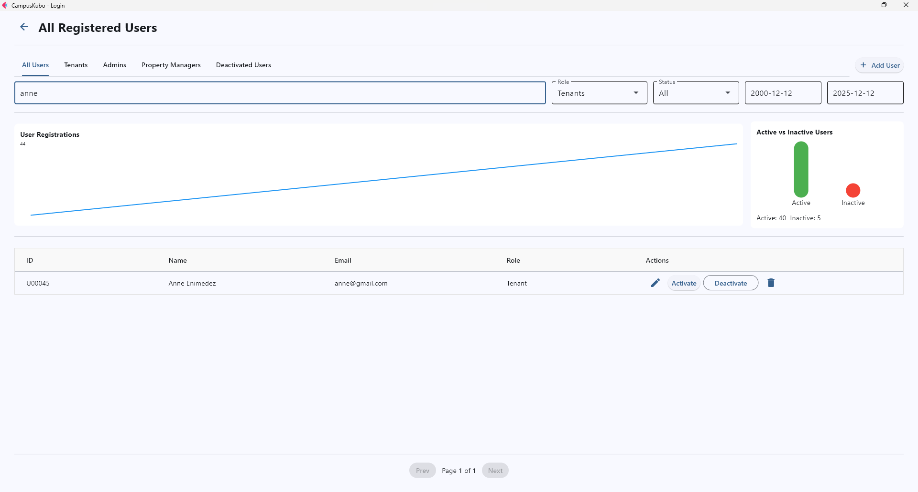Active Search Filters
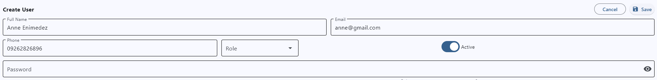
Create/Edit User Info Form

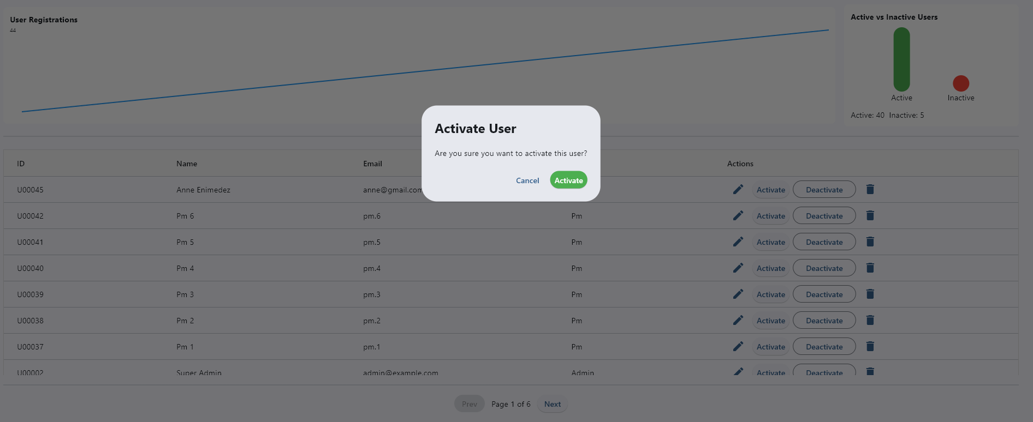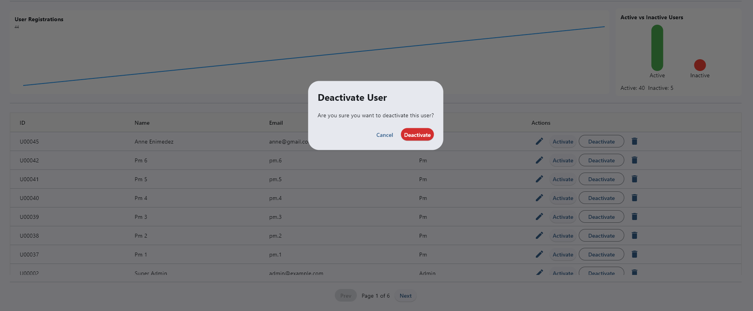
Activation and Deactivation of User

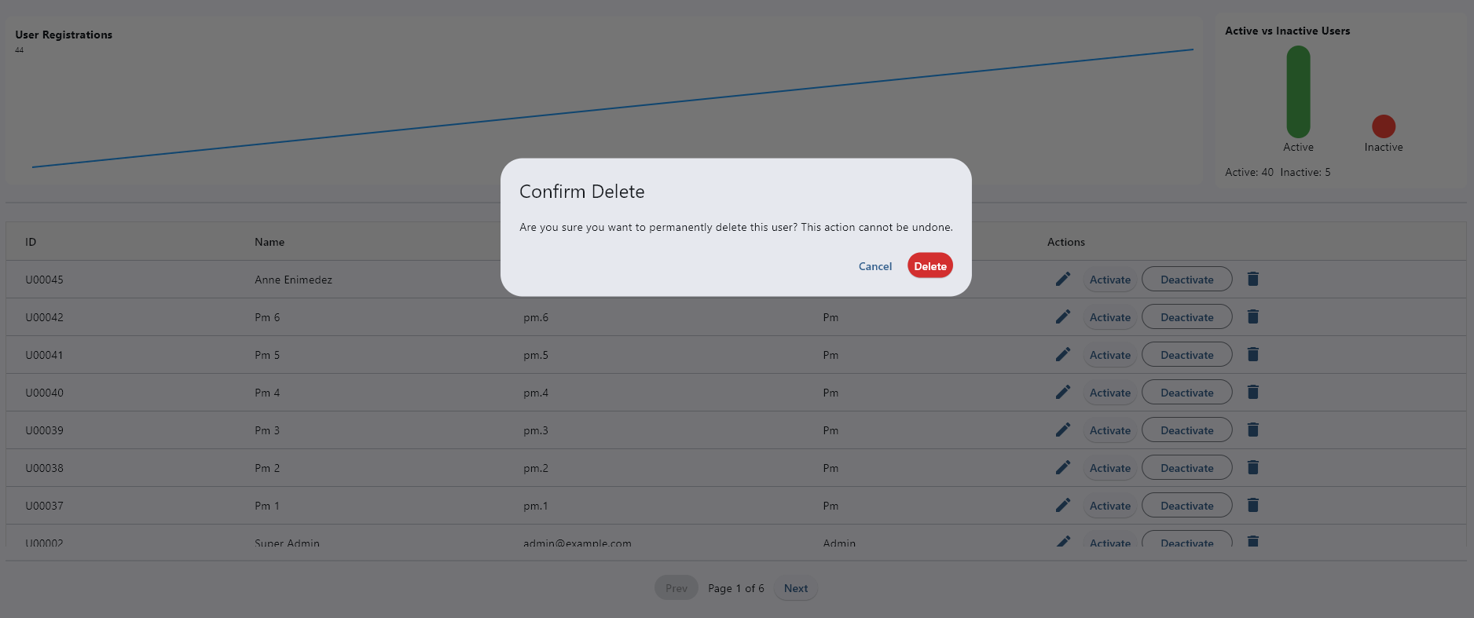
Deletion of User

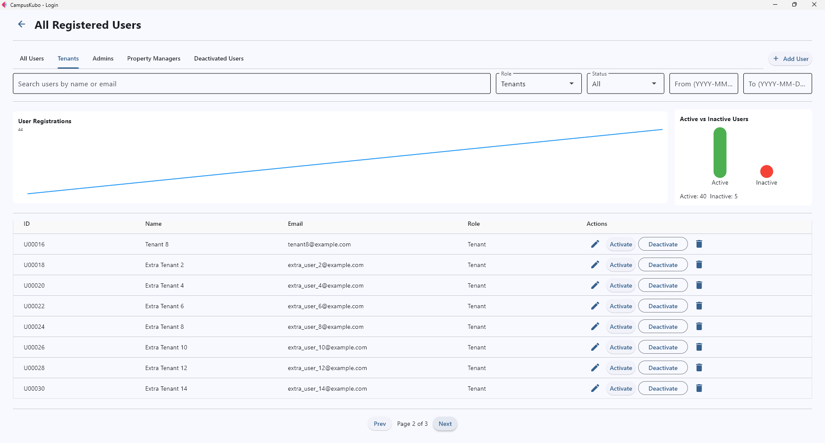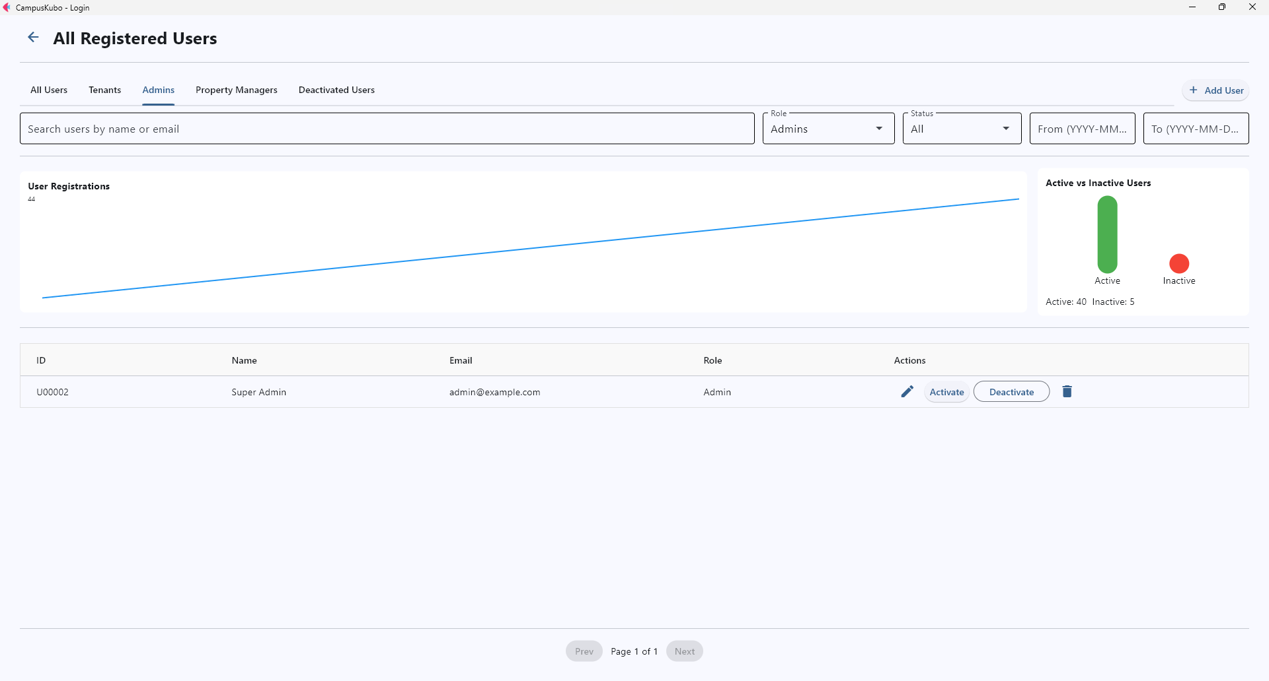
Tenants Tab Admins Tab
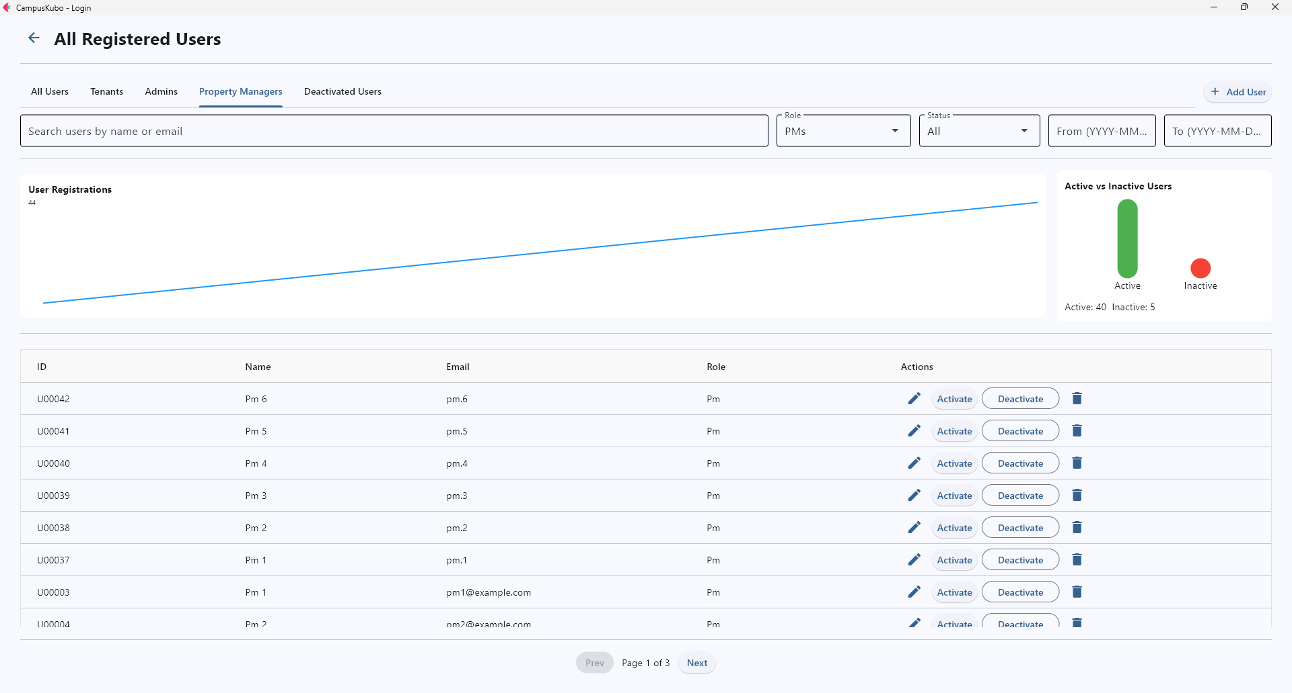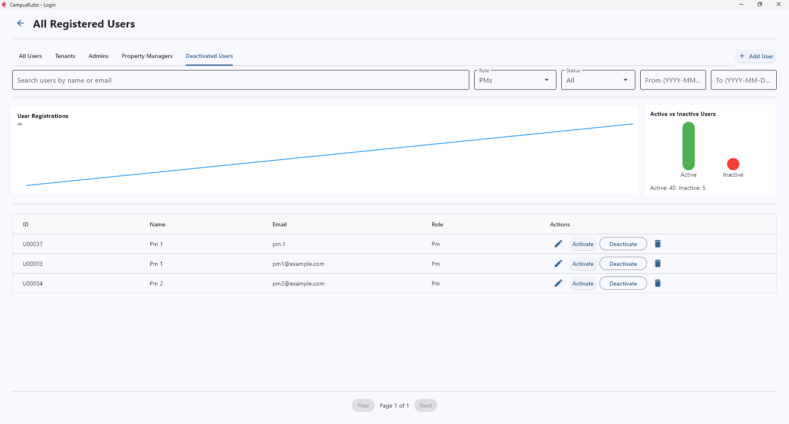
PMs Tab Deactivated Users Tab

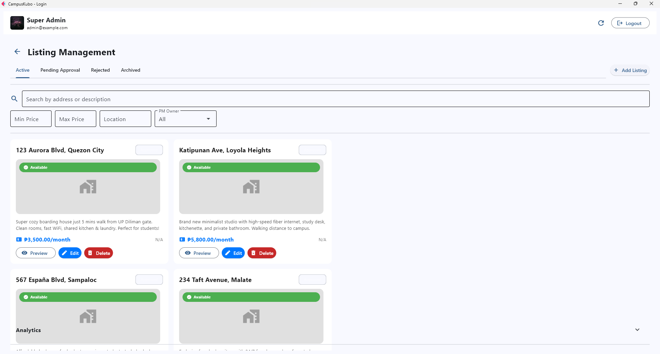
Listing Management Page

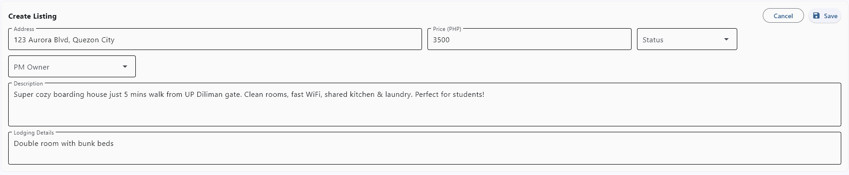
Create/Edit Listing Form

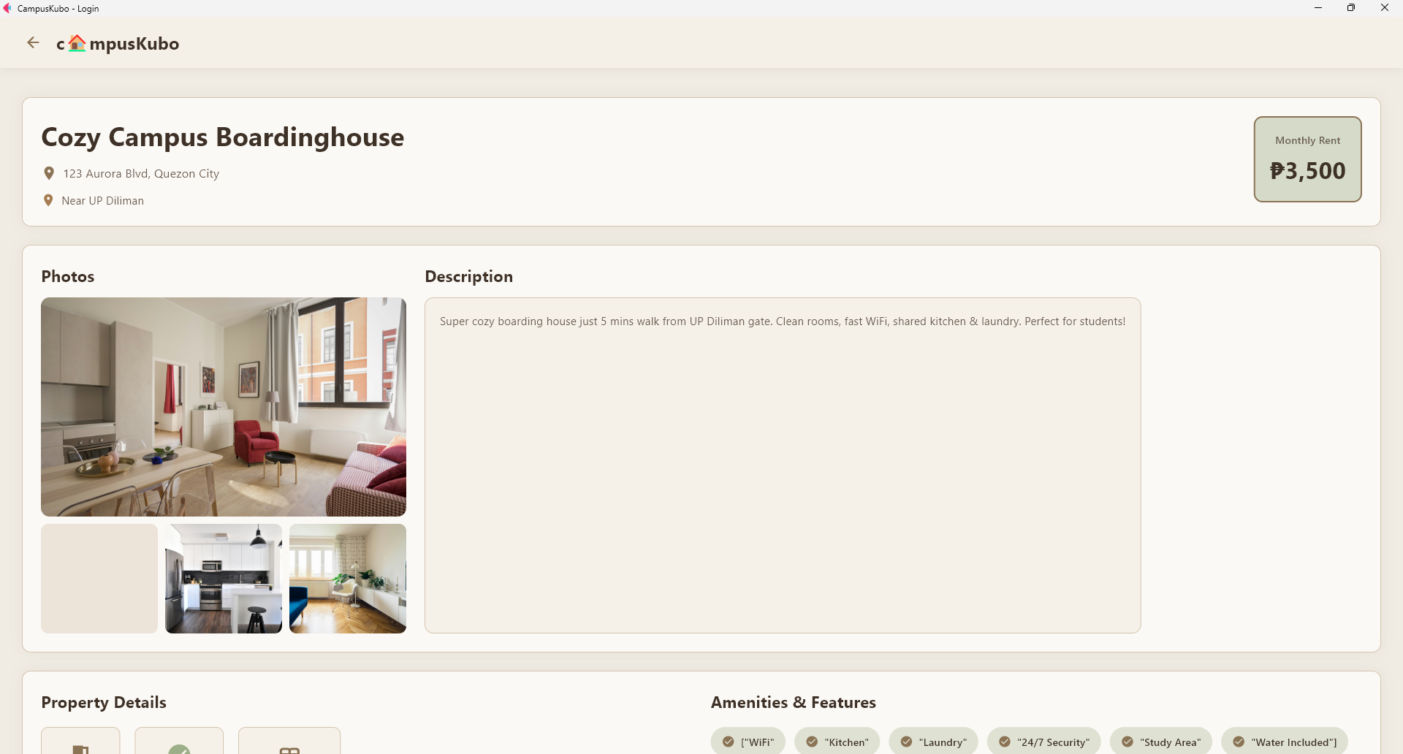
Preview Property Page

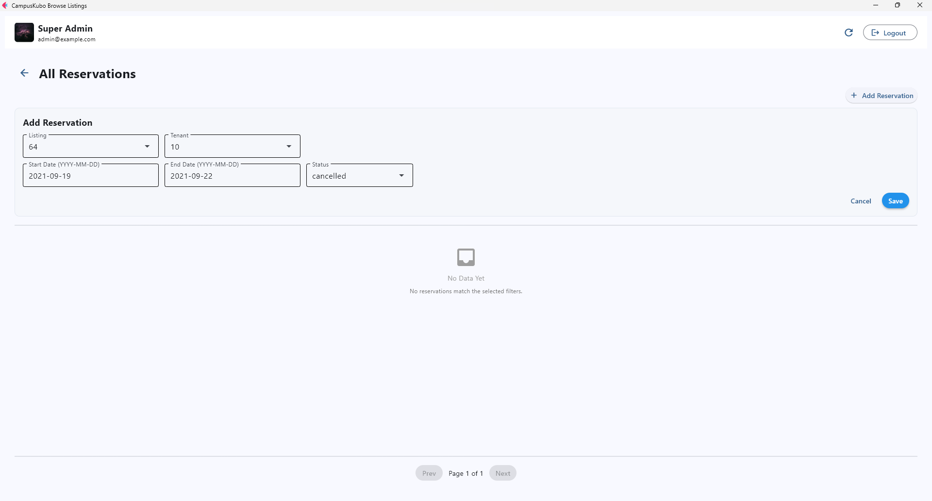
Reservations Page with Add Reservation Feature

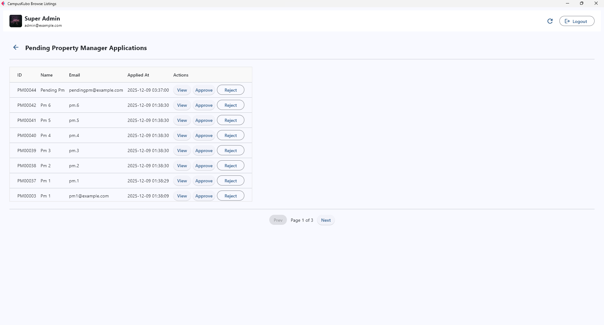
Pending PM Applications Page

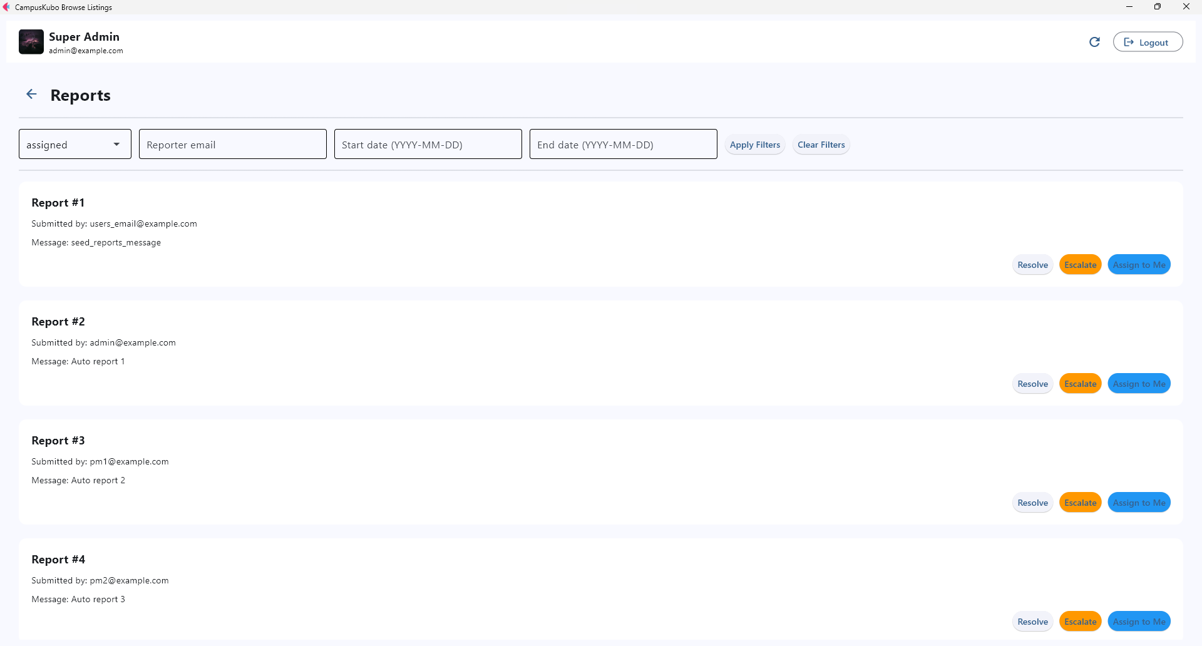
Reports Page with Active Search Filter

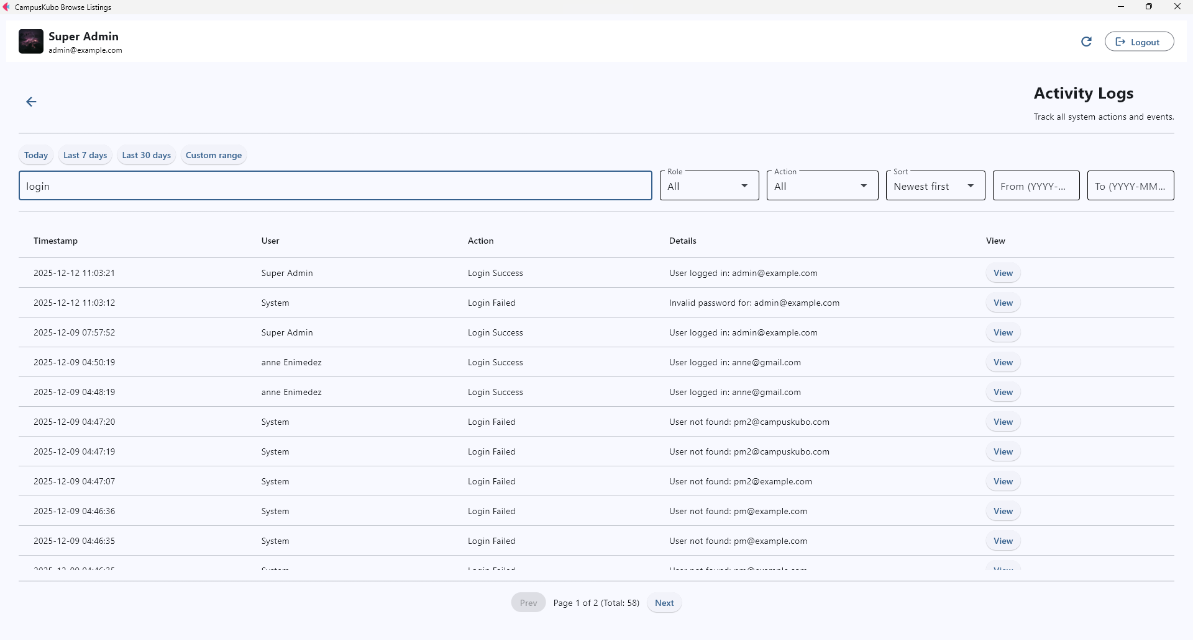
Activity Logs Page with Active Search Filter

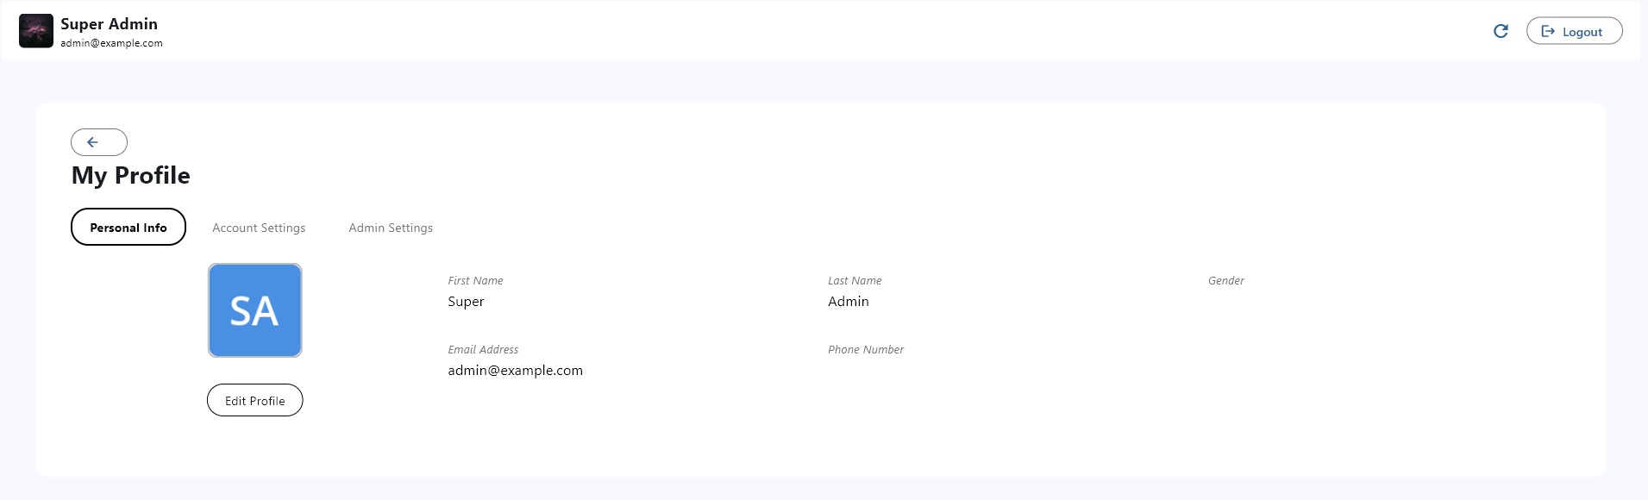
Admin Profile Page

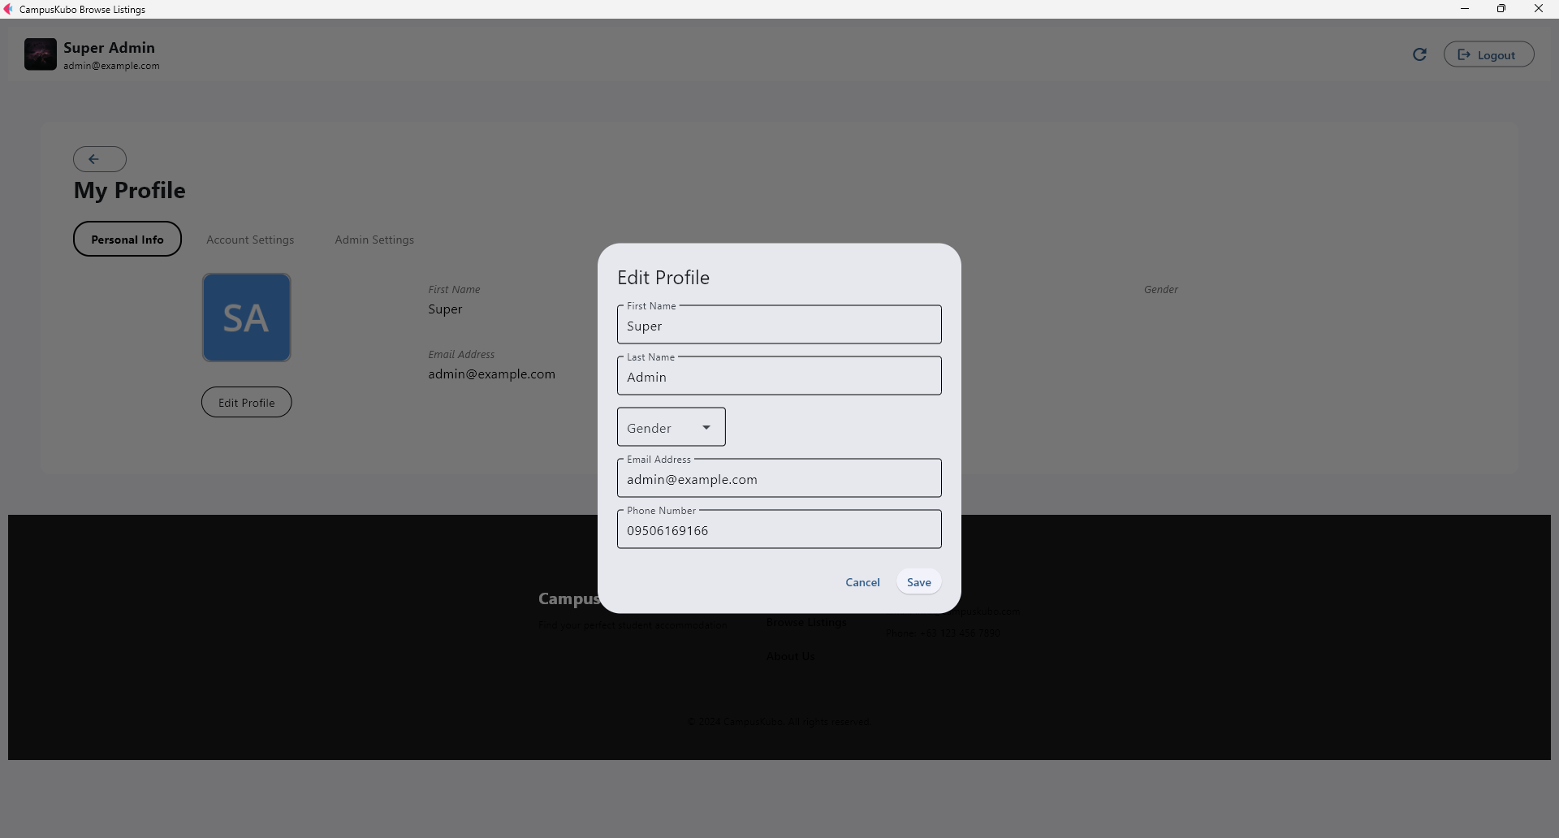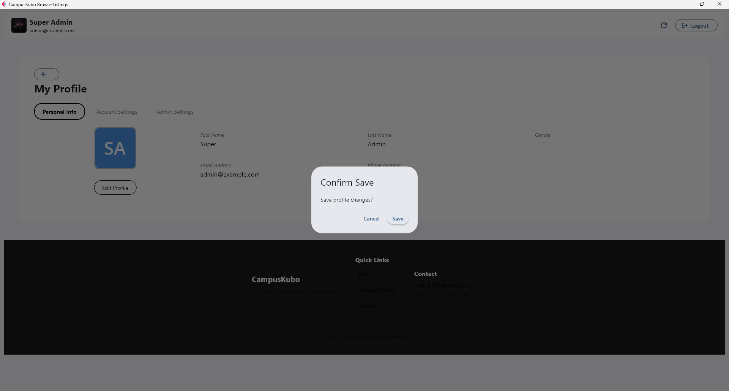
Personal Info Tab with Edit Form and Confirmation Dialog

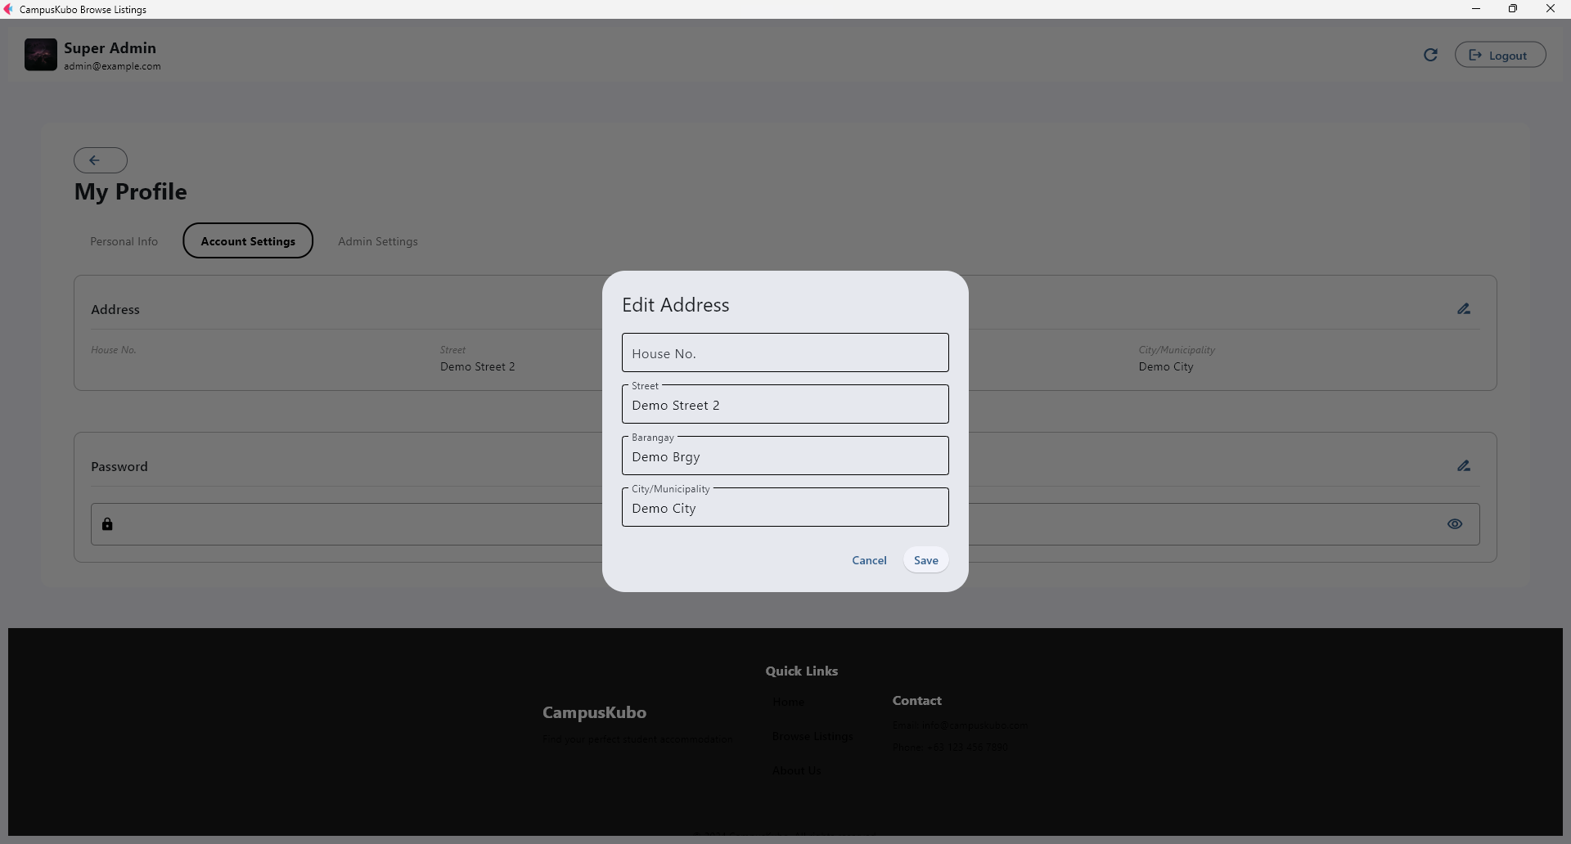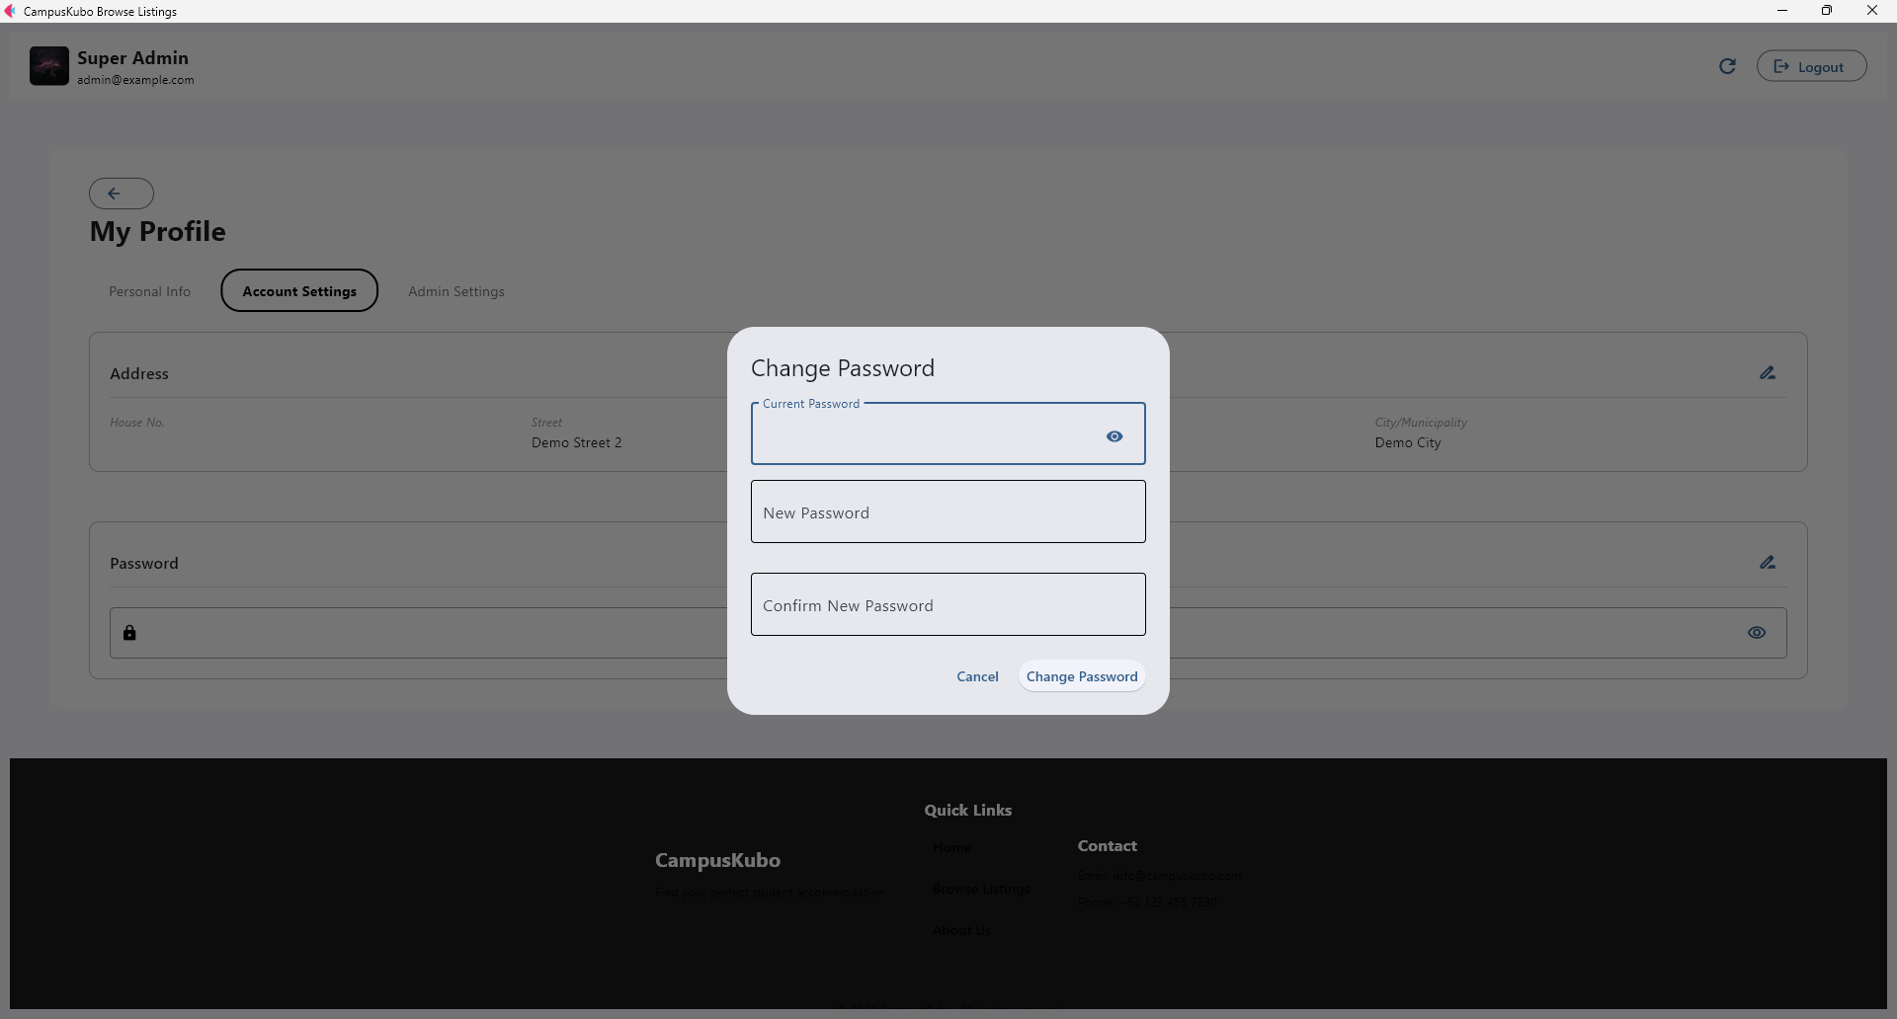
Accounts Settings Tab with Edit Address and Change Password Forms

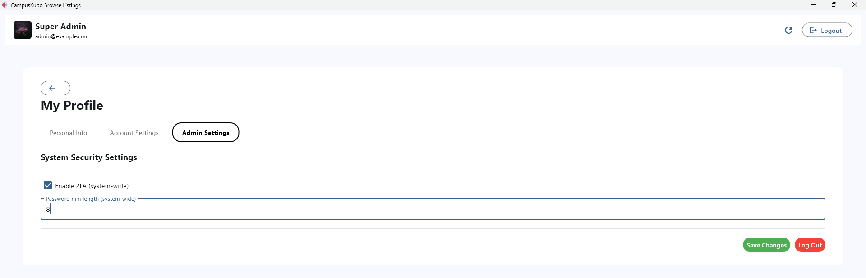
Admin Settings Tab

- Property Manager Dashboard: Images carousel, description, amenities, reserve button.

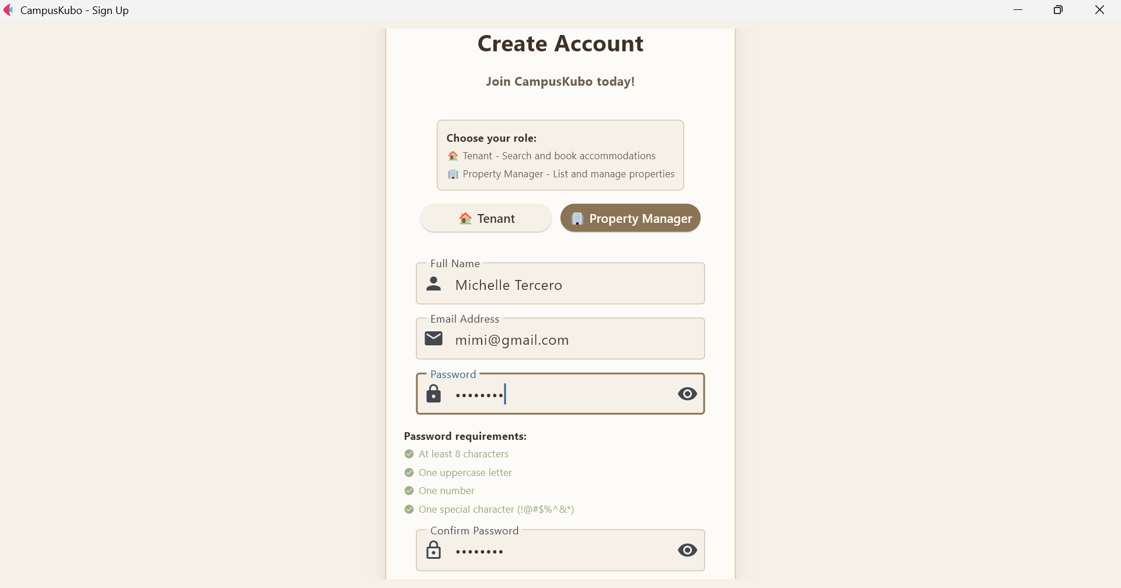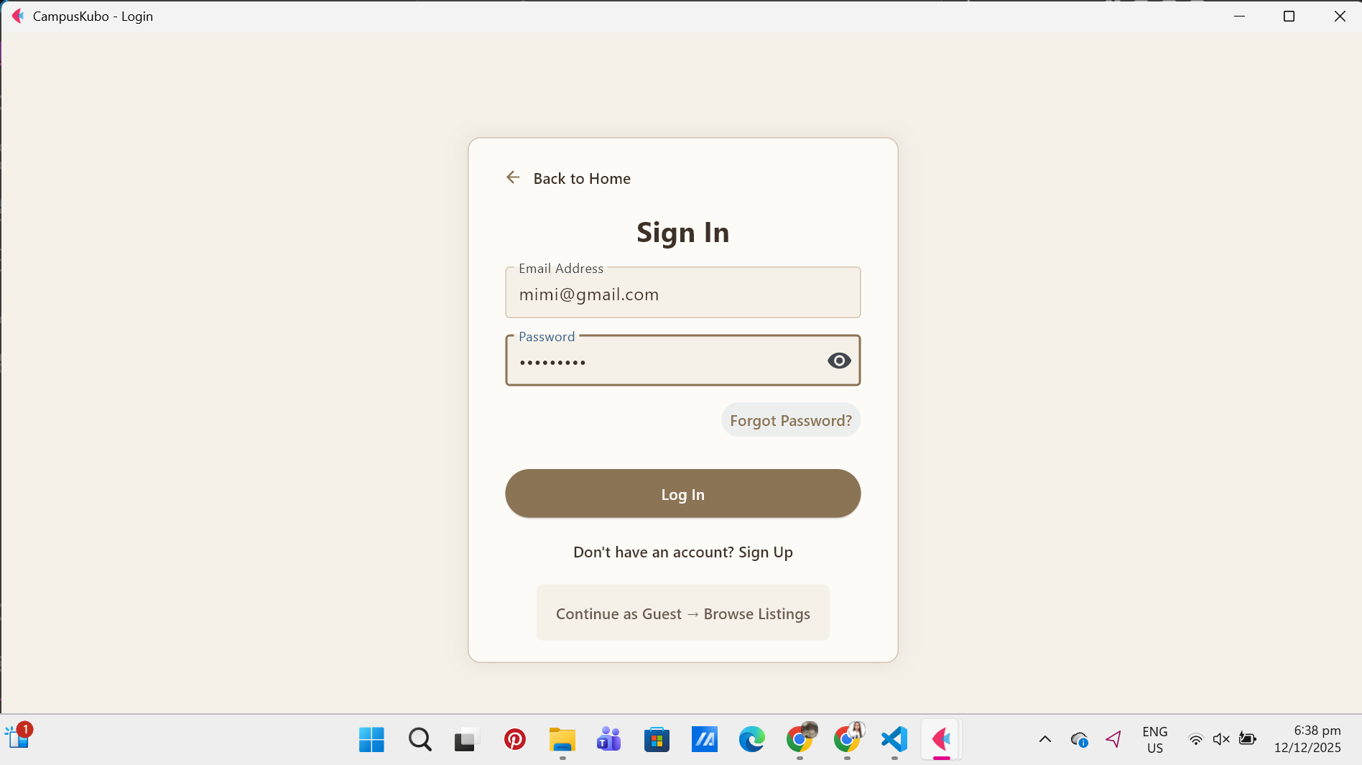
Sign up Login

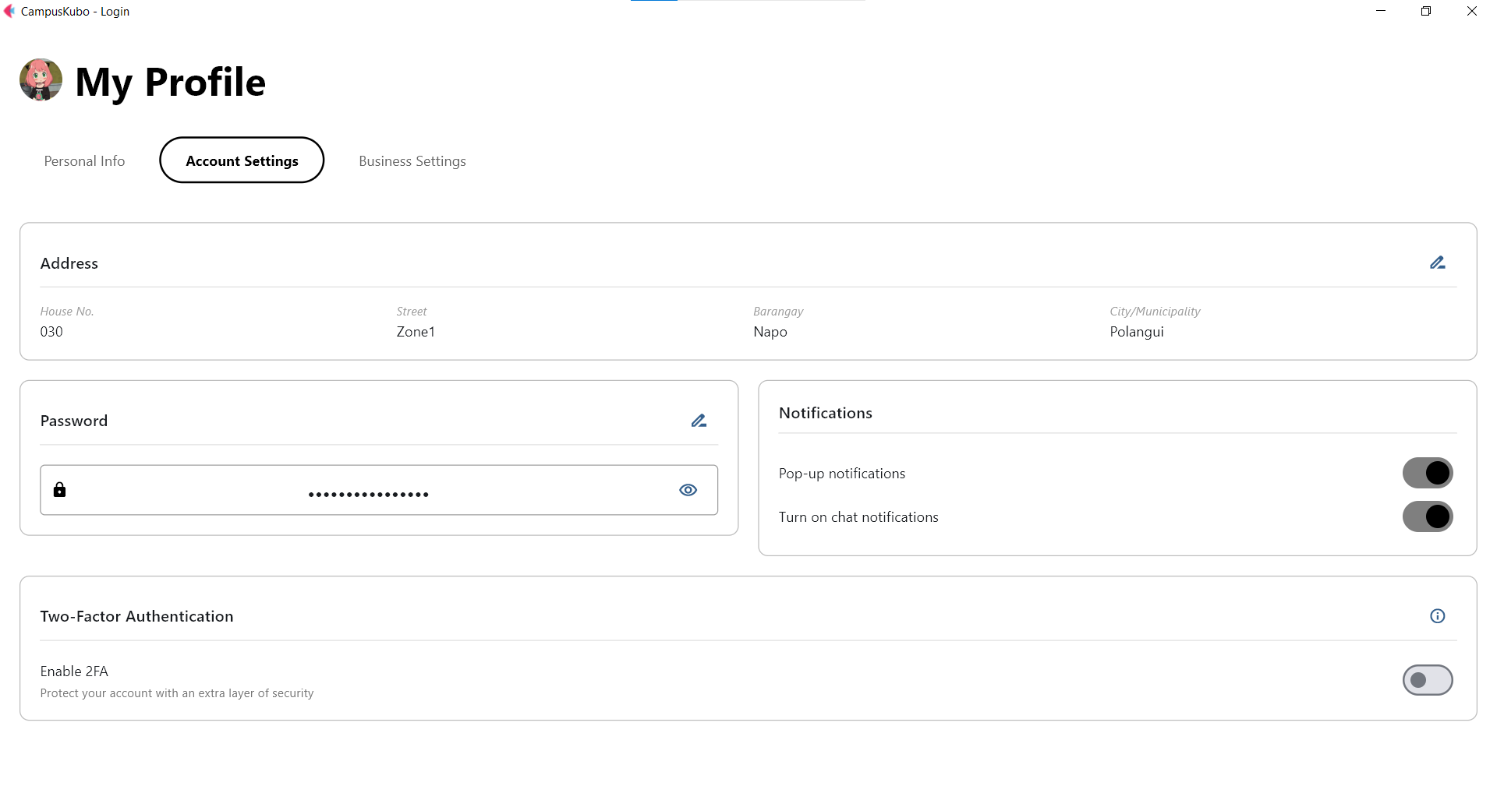
PM - Account settings

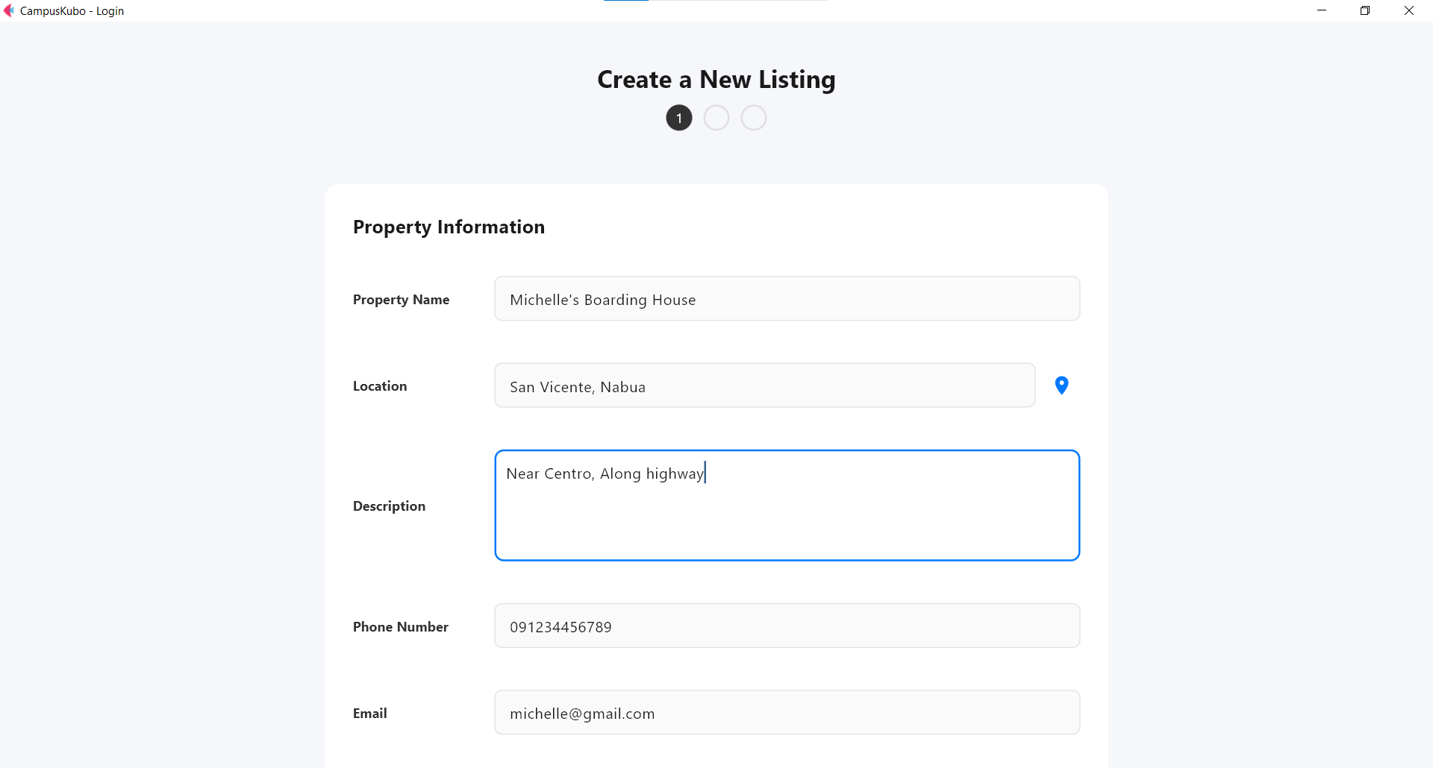
Adding a new property listing, showing basic property information fields.
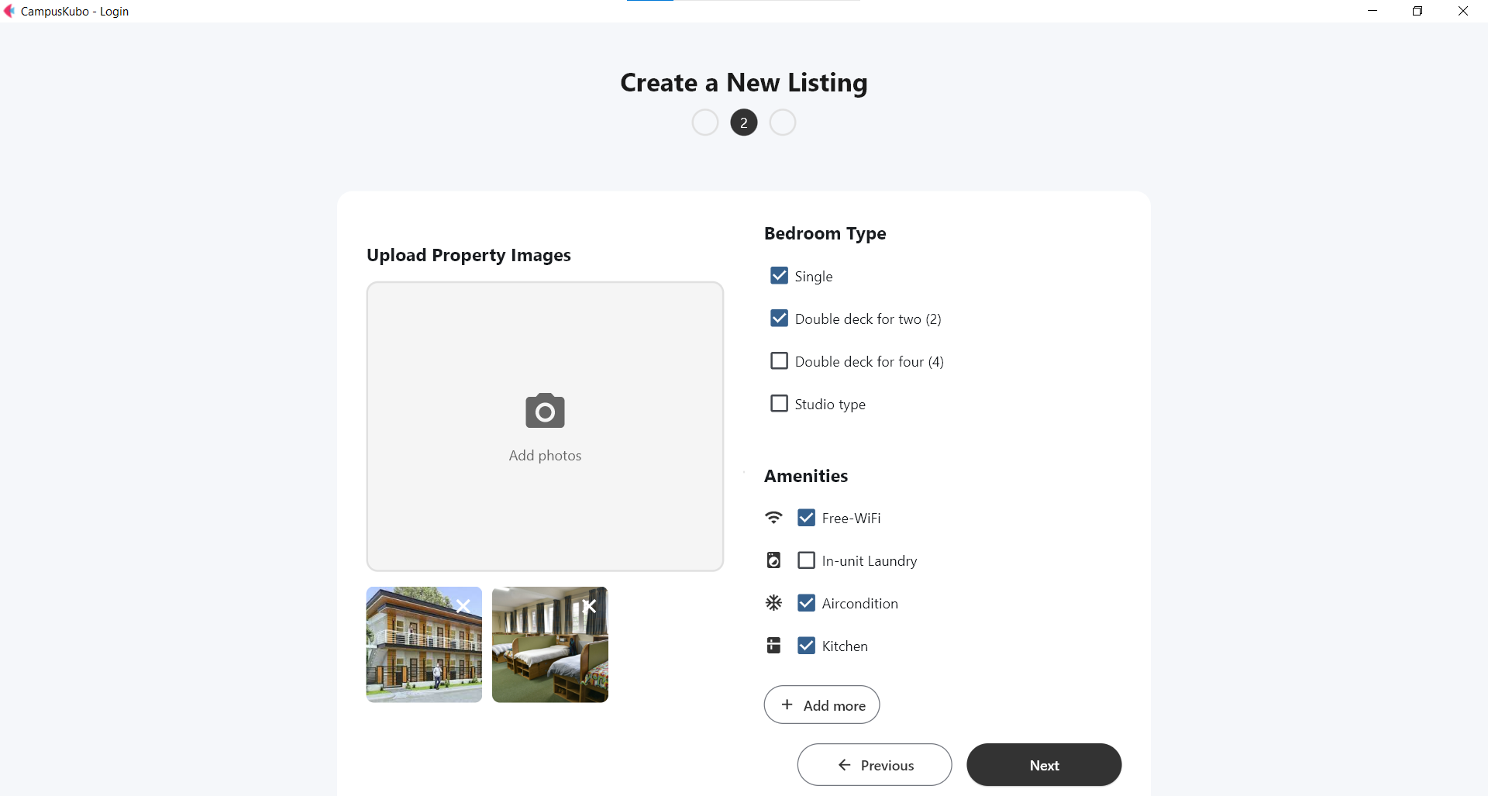
Allowing users to input additional property details.

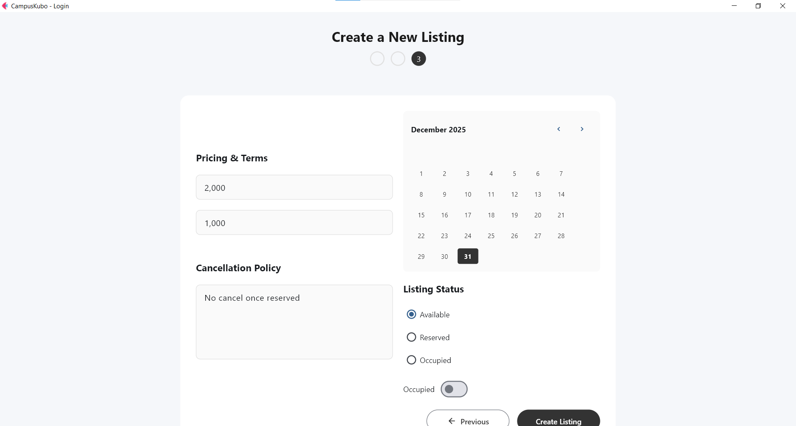
Confirmation and summary of entered details.

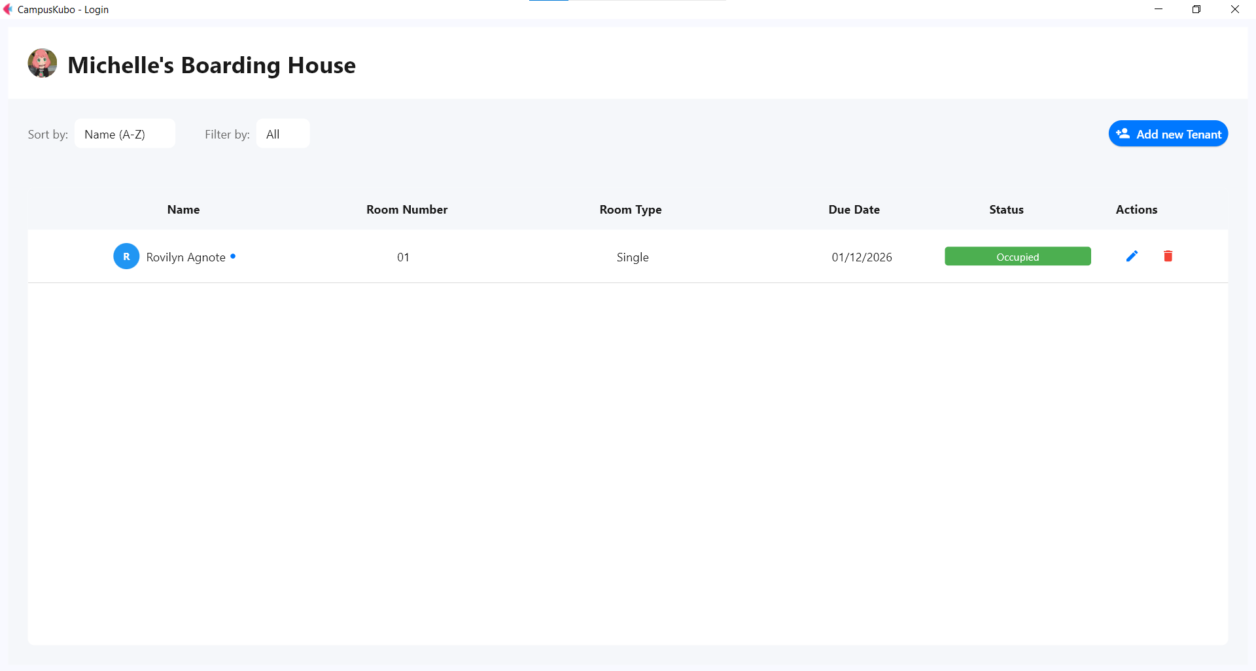
Interface for adding a tenant to a selected property.

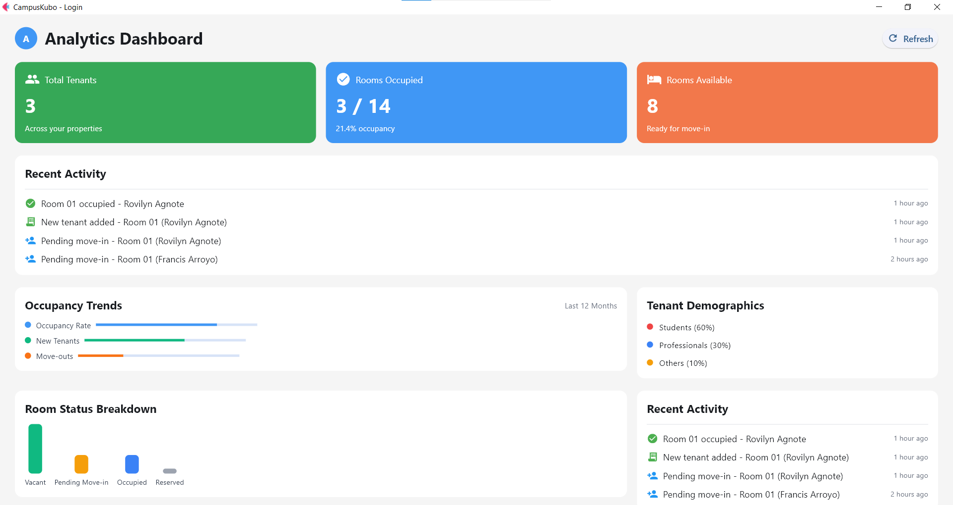
Overview page showing summarized data for all properties managed by the user.
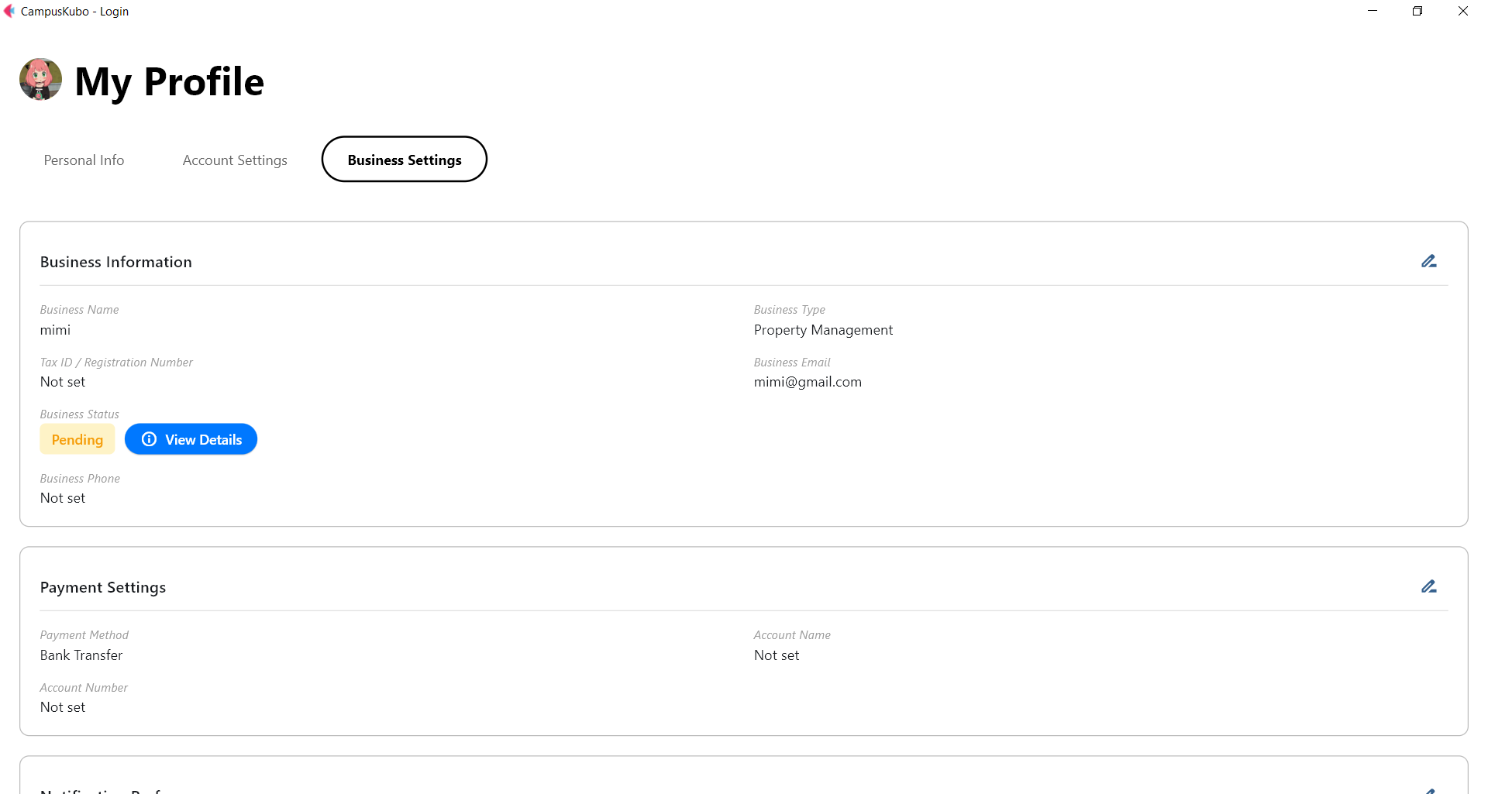
Business information and preferences

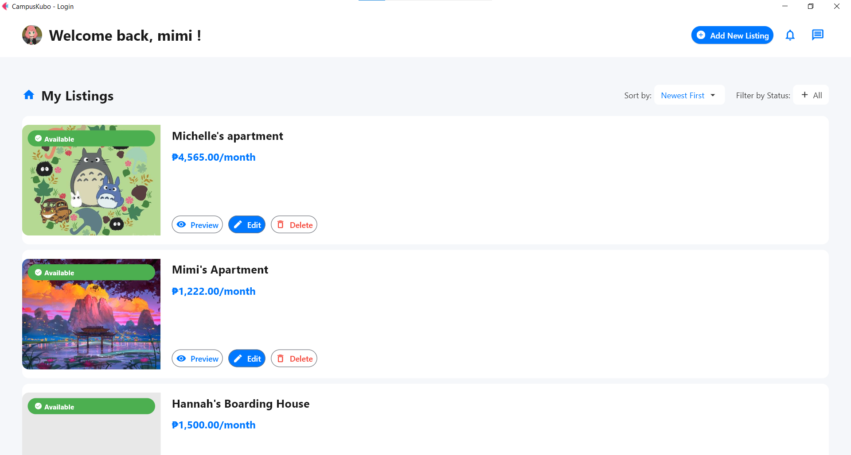
Main dashboard

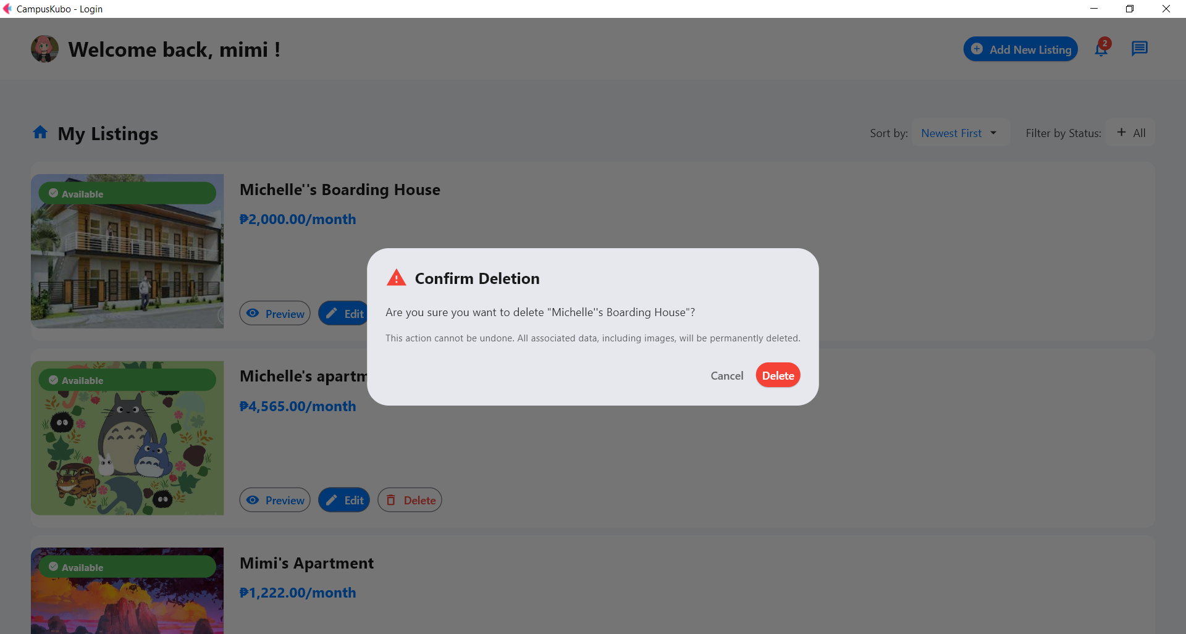
Dashboard view showing the delete confirmation

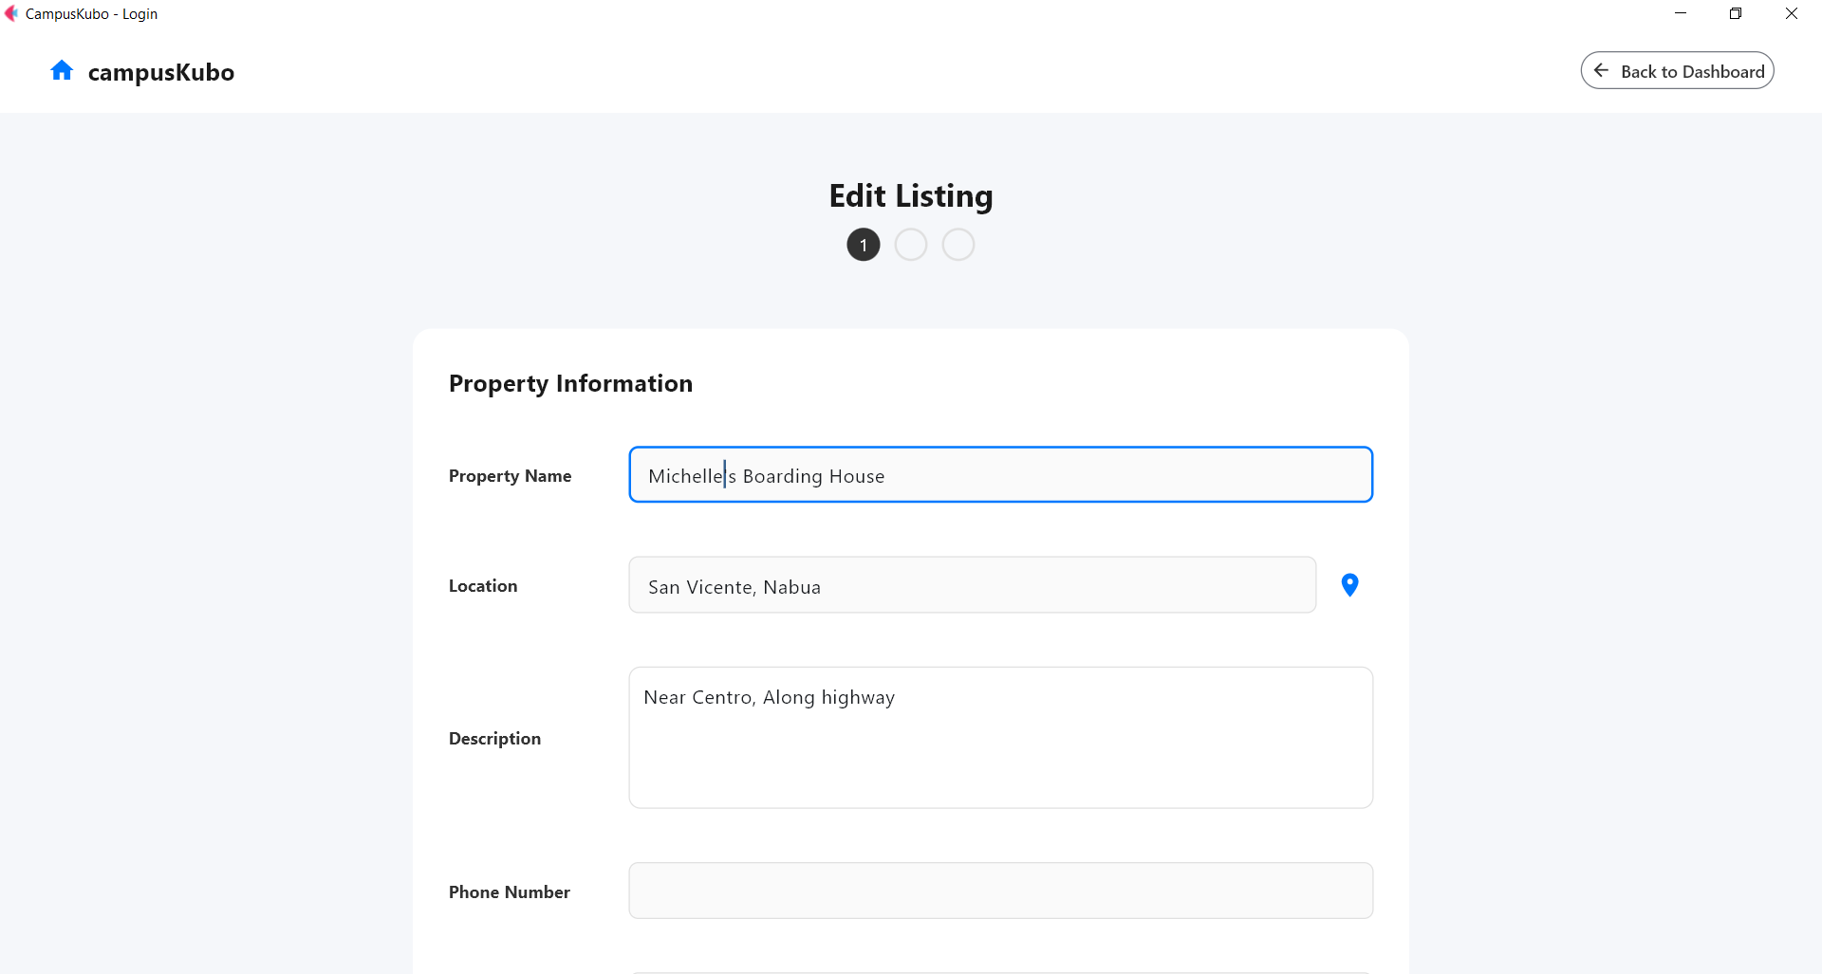
Page where users can modify an existing property listing.

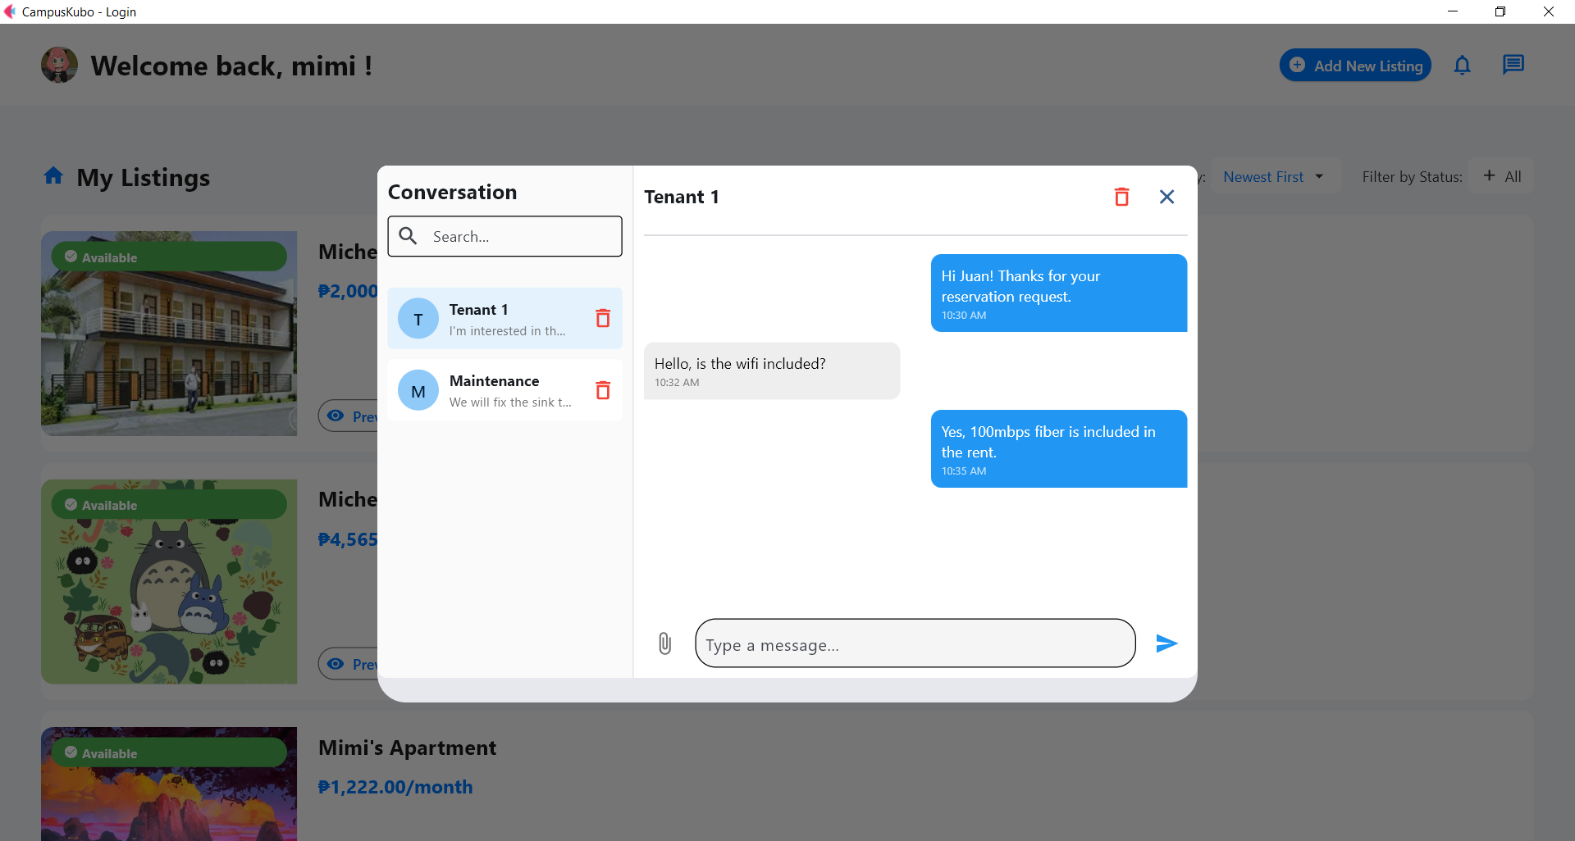
Messaging interface for communicating with tenants or other users.

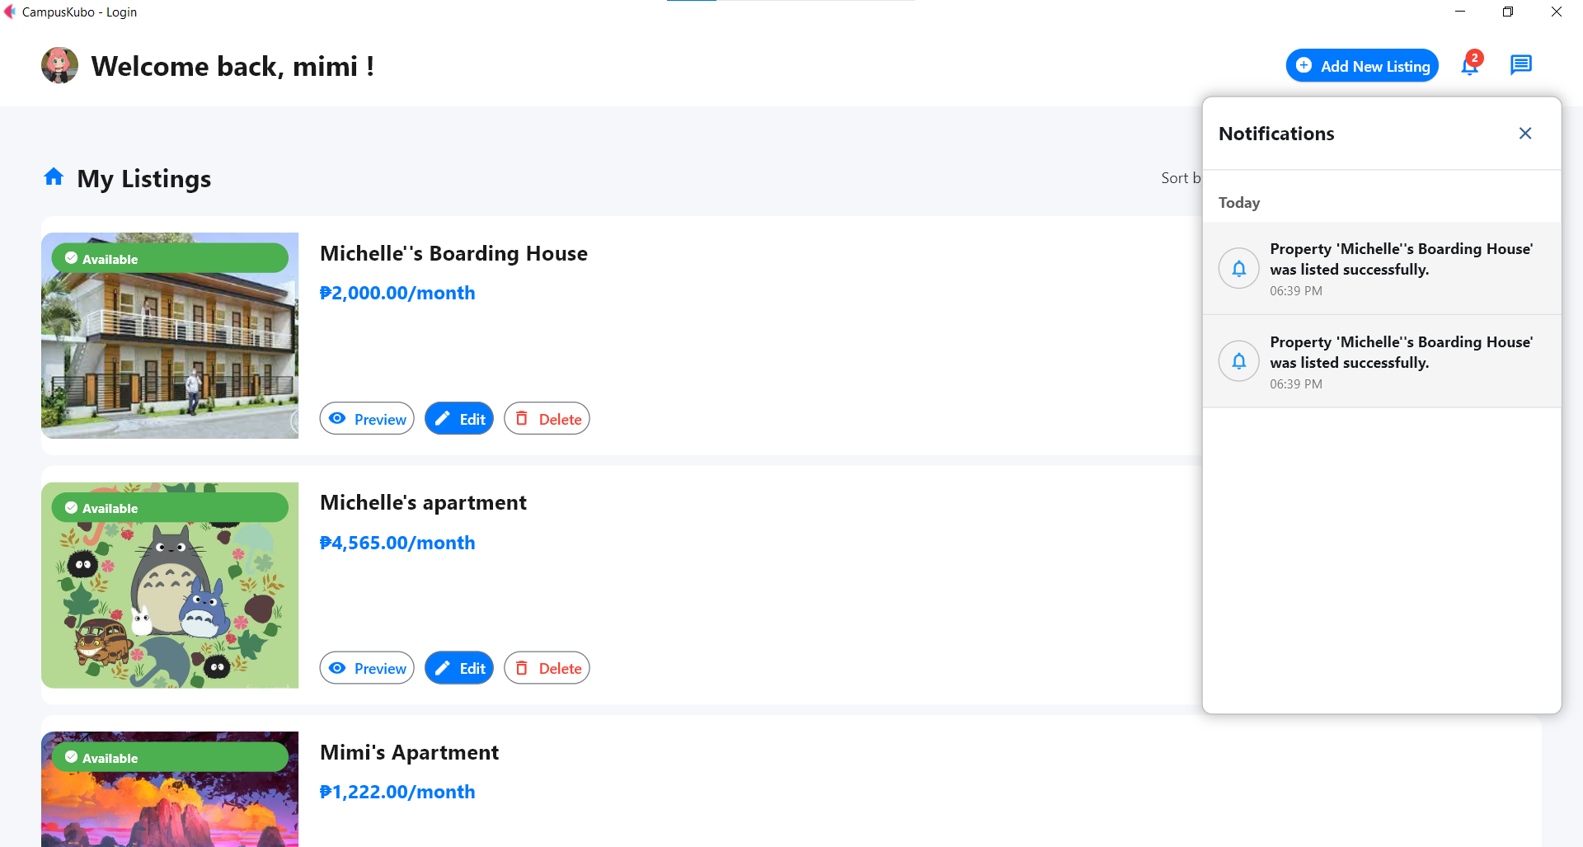
Notification center showing system alerts, updates, and reminders.

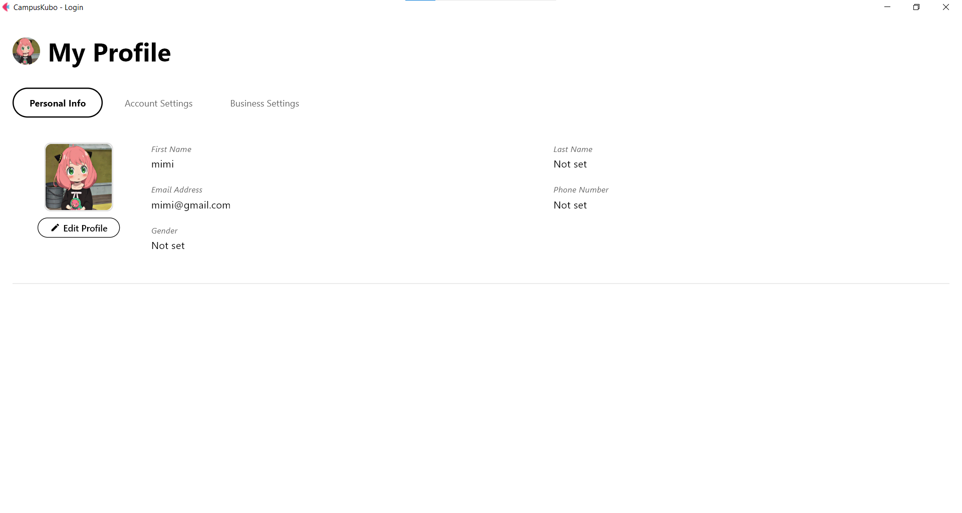
User profile page displaying personal information

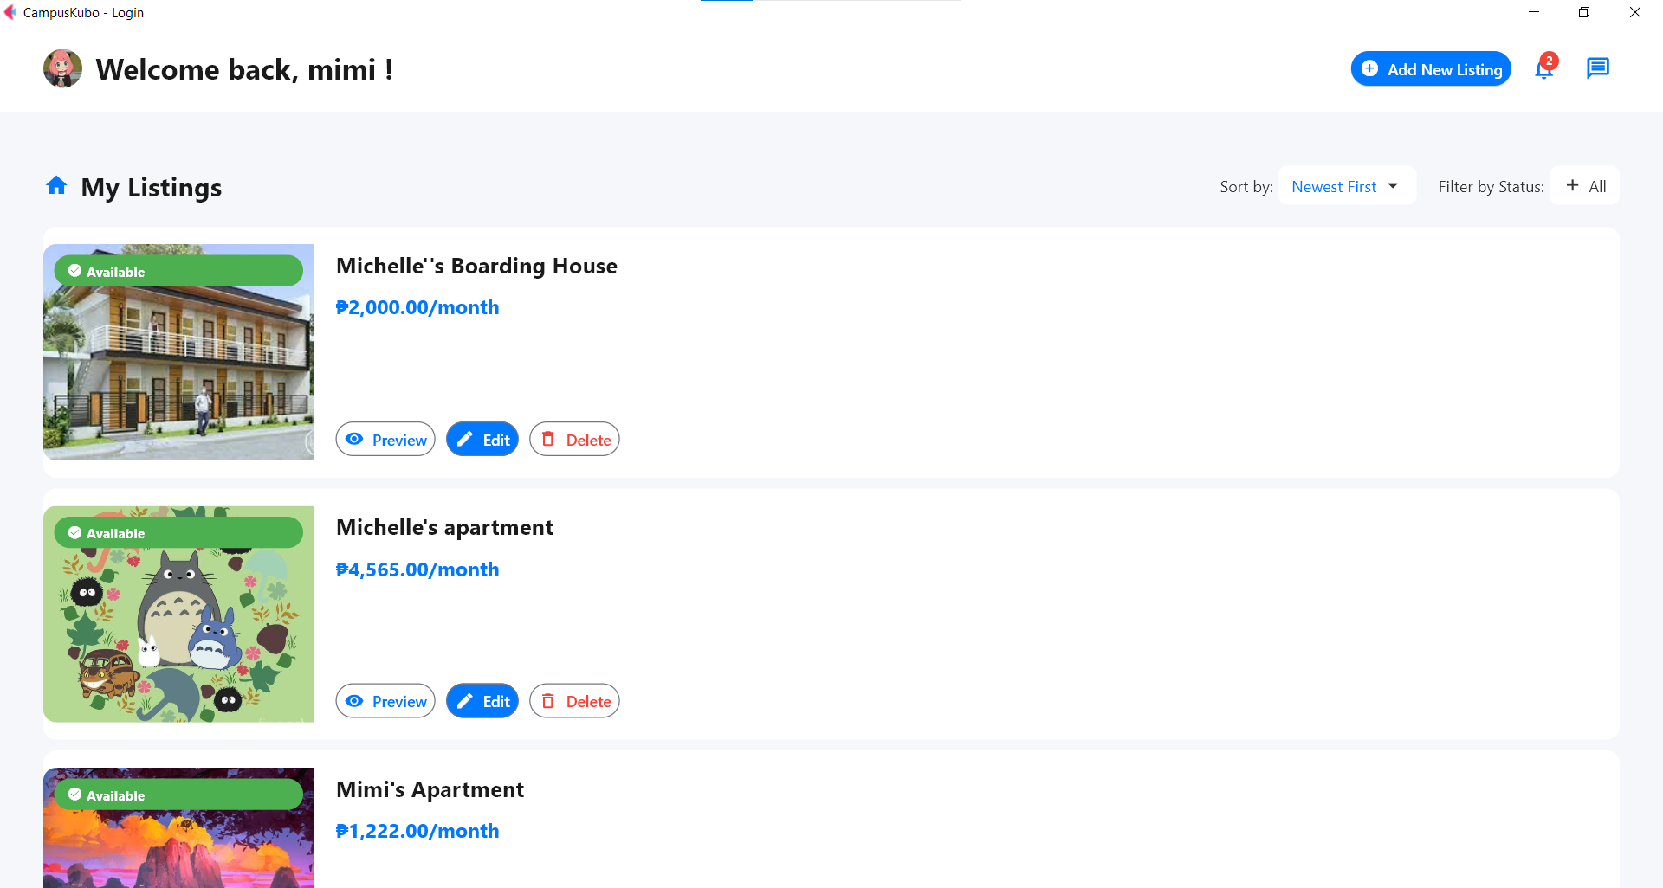
List of all properties currently added

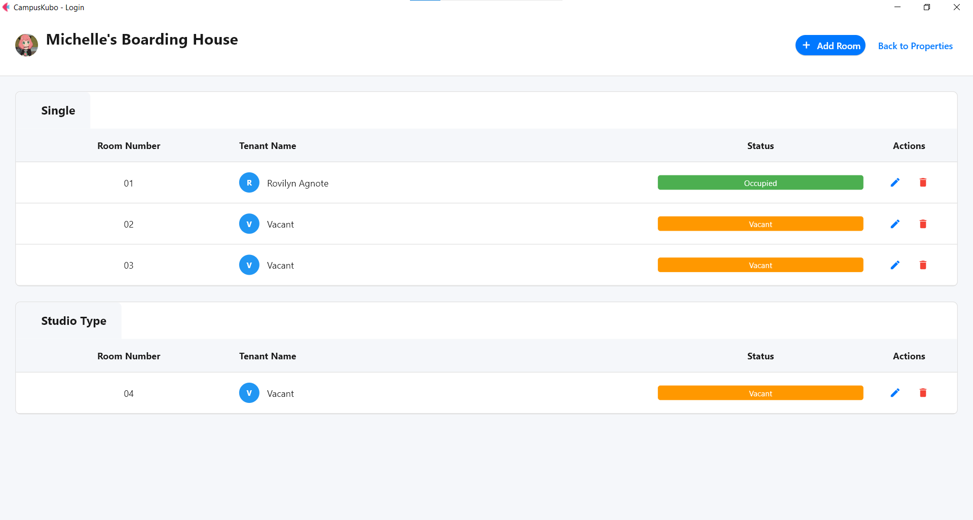
Page for adding rooms to a property and configuring monitoring details.

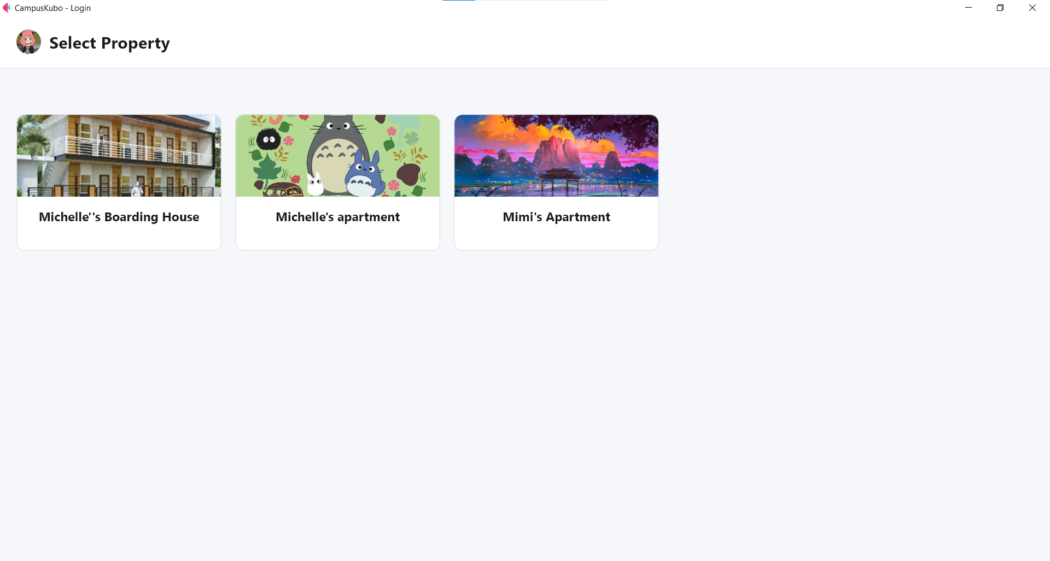
Screen where users select a property before managing its rooms.

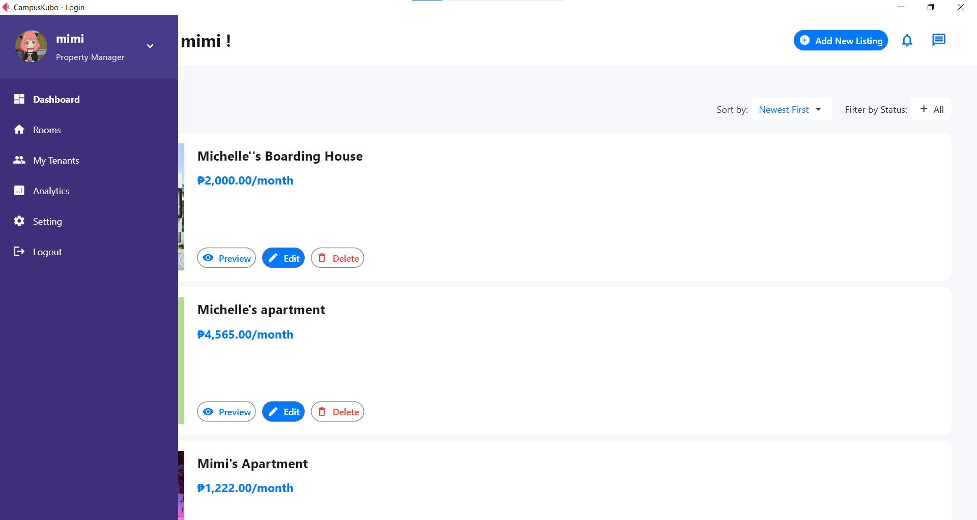
Sidebar navigation menu showing available modules and quick links.

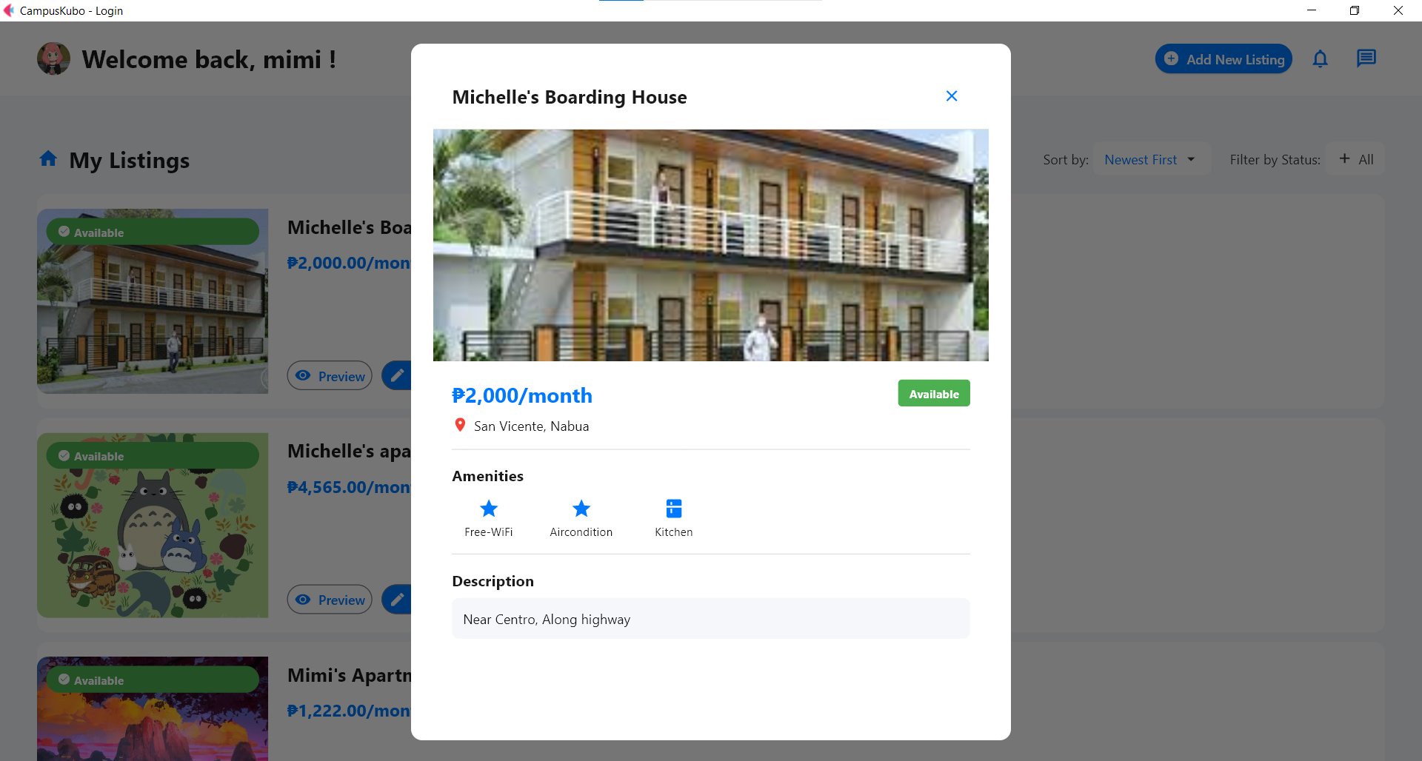
Showing how a property listing will appear before publishing.

- Tenant Dashboard: (add description)
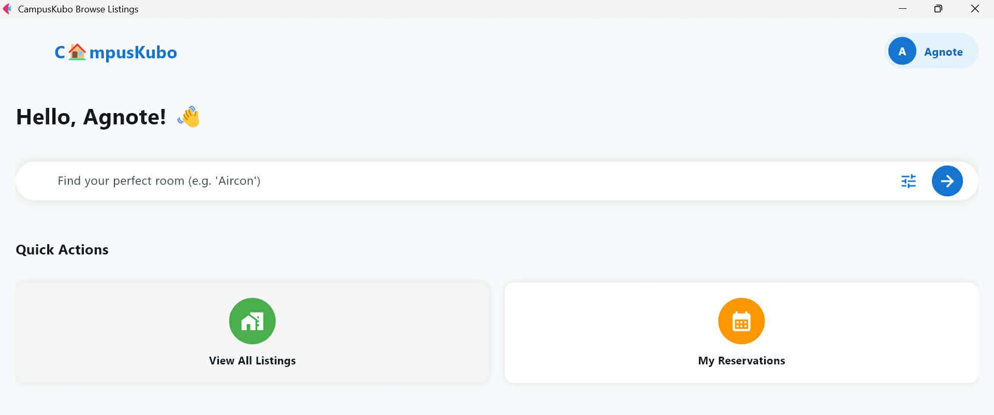
Greets the user and provides quick access to listings, and reservations.

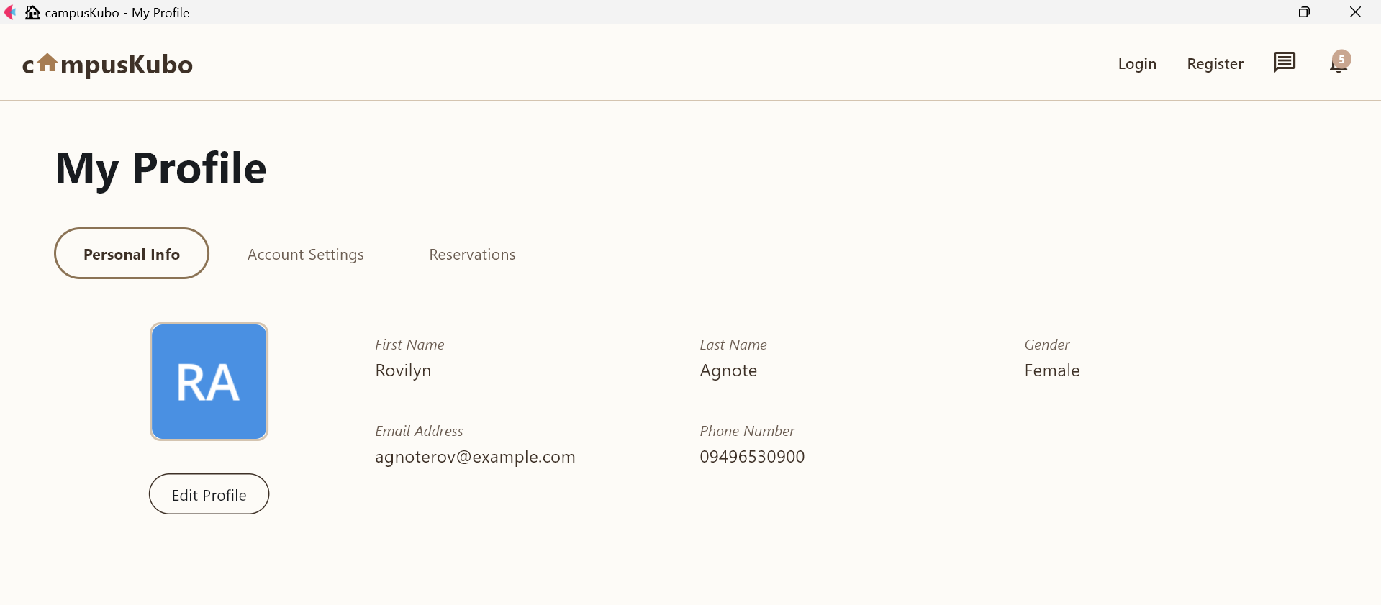
Tenant’s personal info like name, email, and phone number.

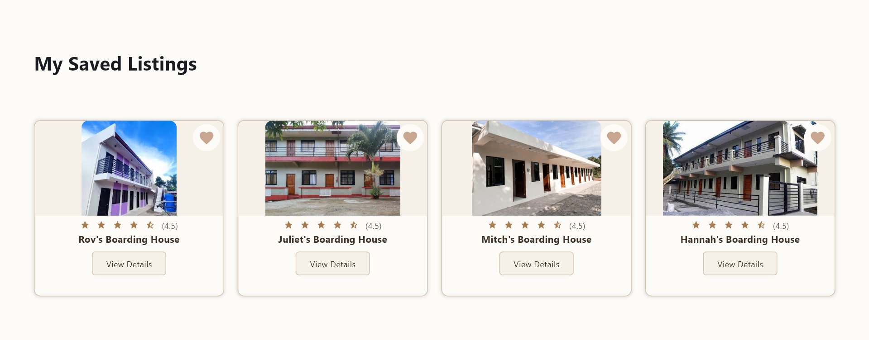
Shows favorited boarding houses with ratings and view buttons.
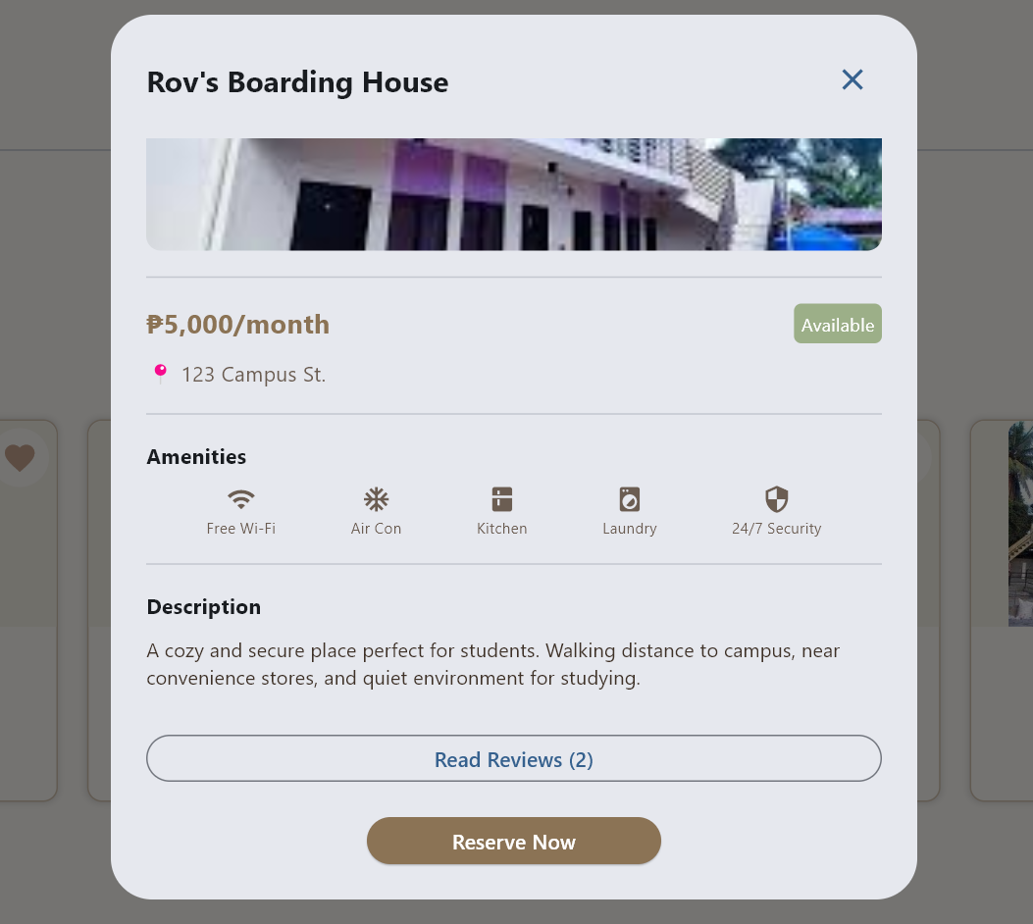
Shows price, address, amenities, and description of a property.

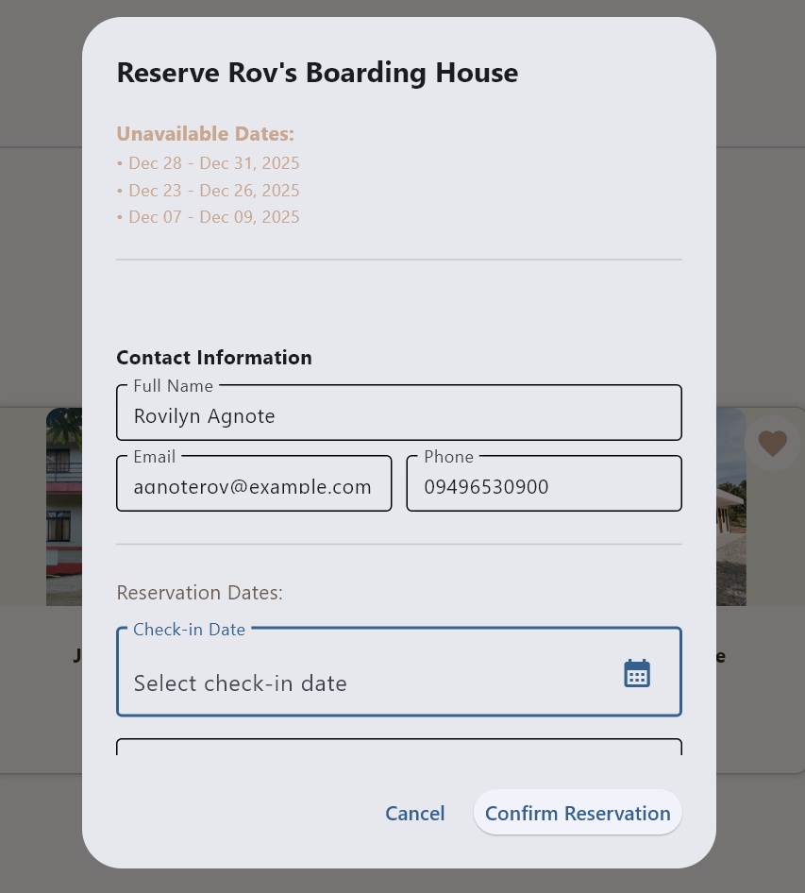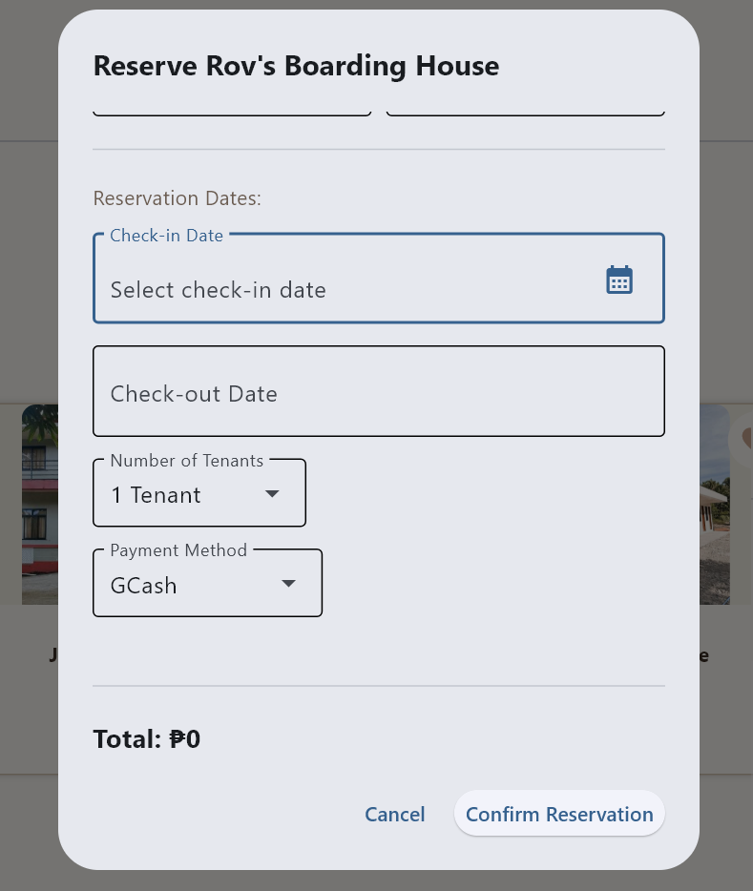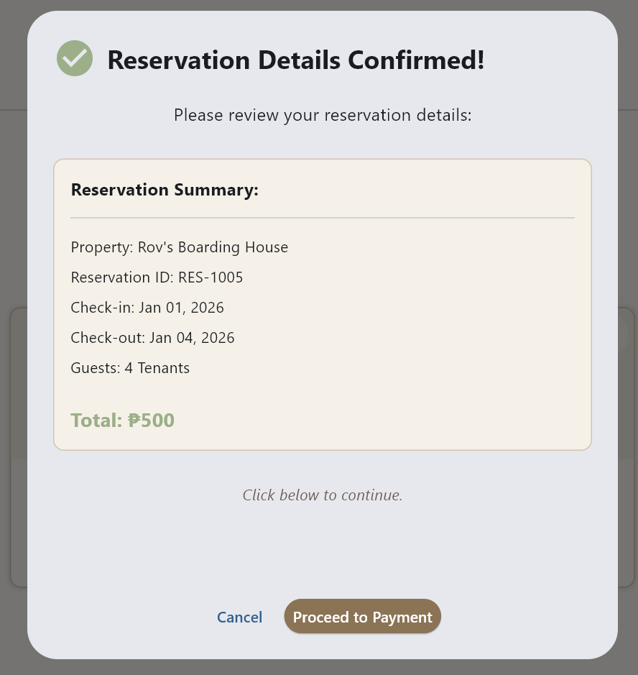
Users can reserve a room by selecting dates, entering contact info, choosing tenants and payment method, then reviewing the booking summary.

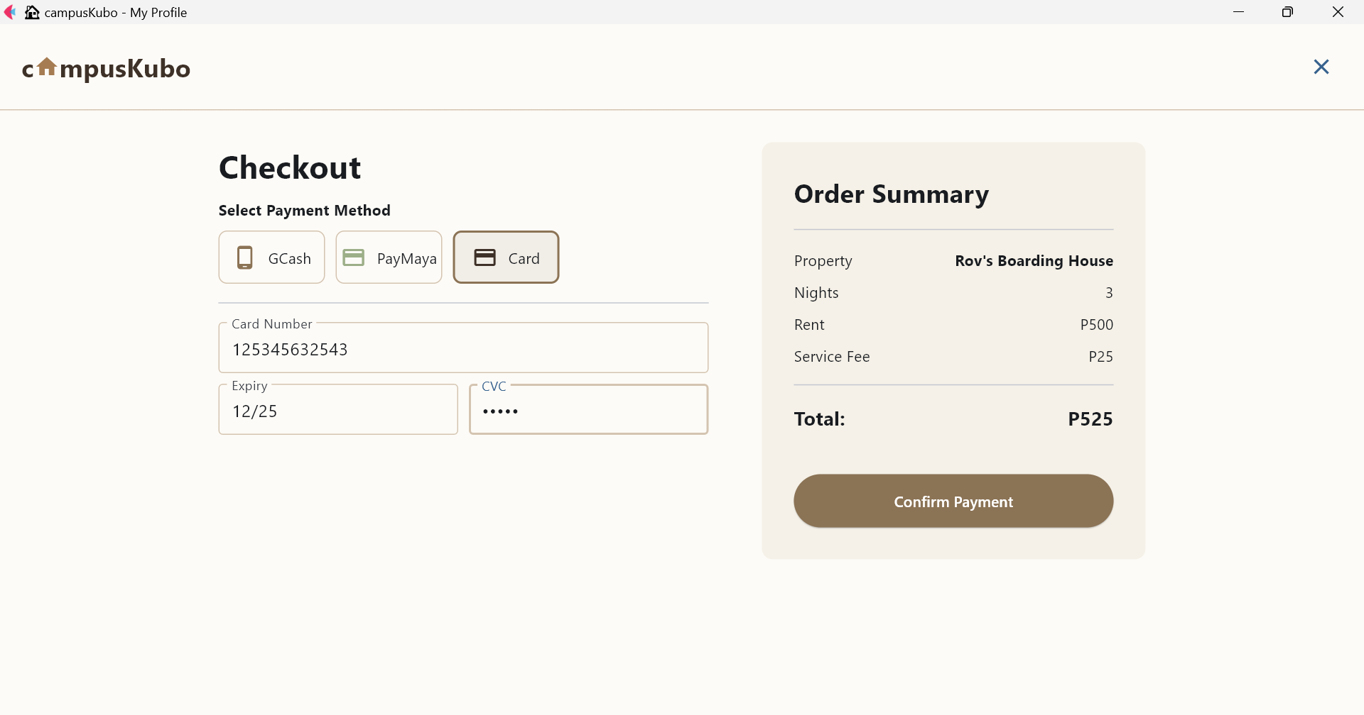
Lets users select payment method and view order summary.
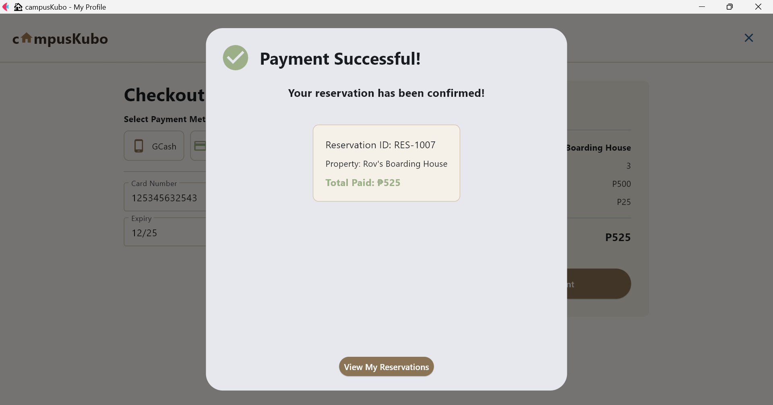
Confirms successful payment and reservation details.

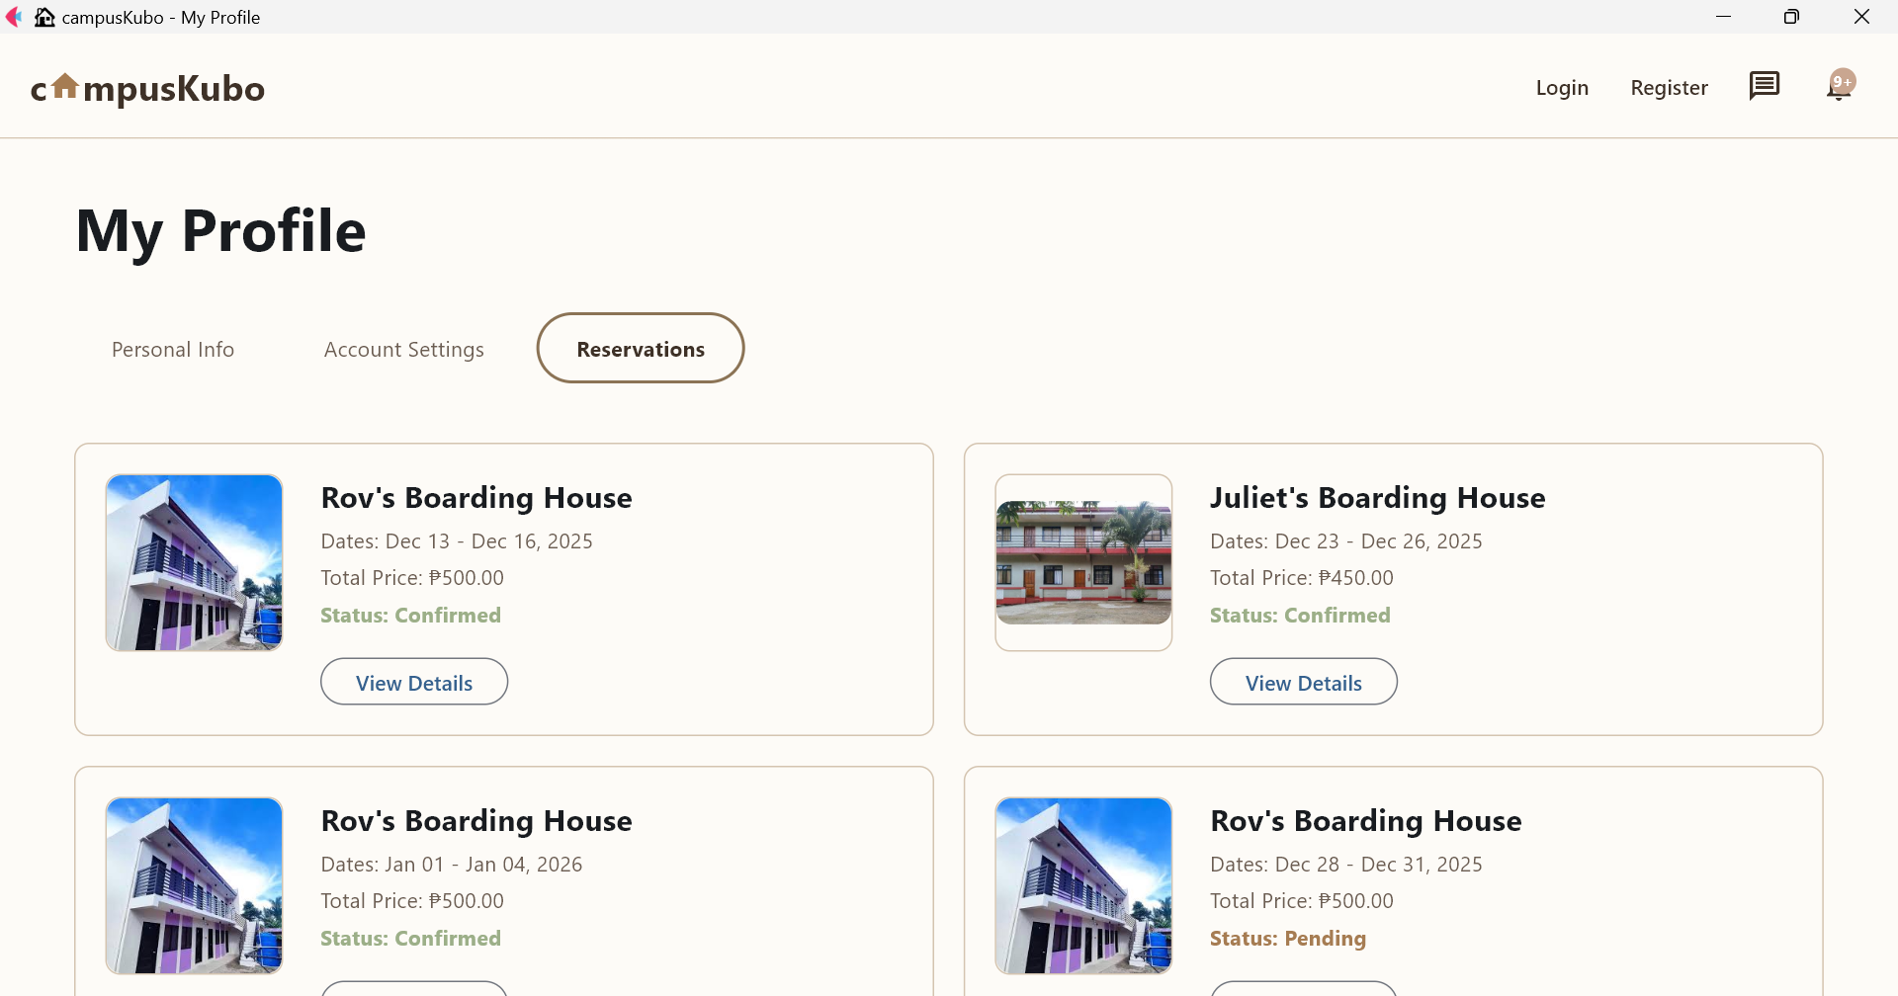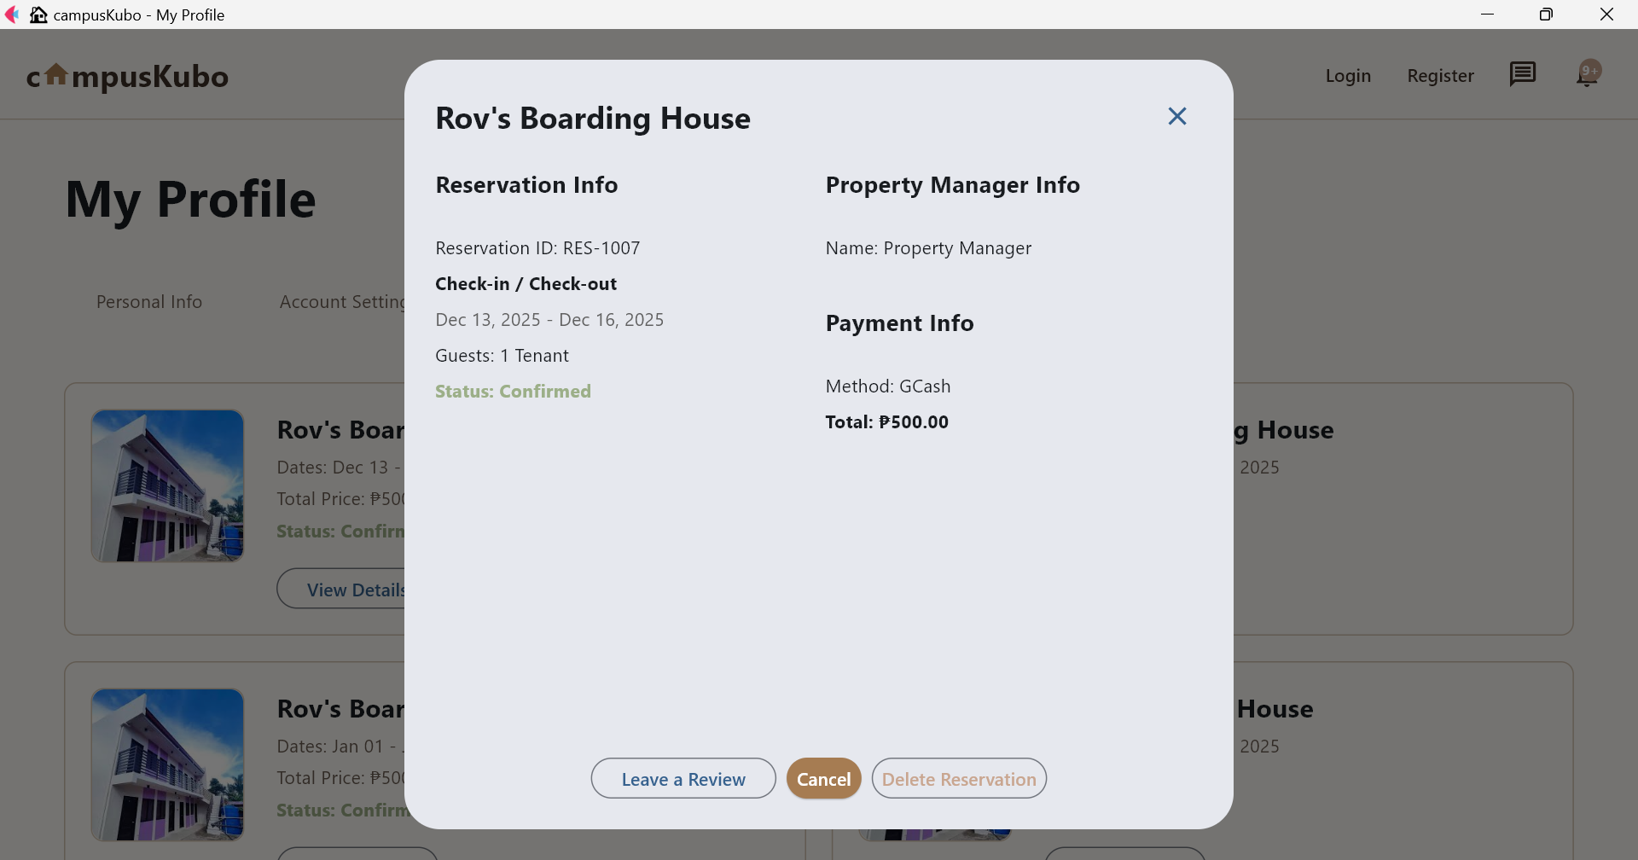
It shows your past and upcoming bookings along with a popup that provides full reservation details, payment info, and manager contact.

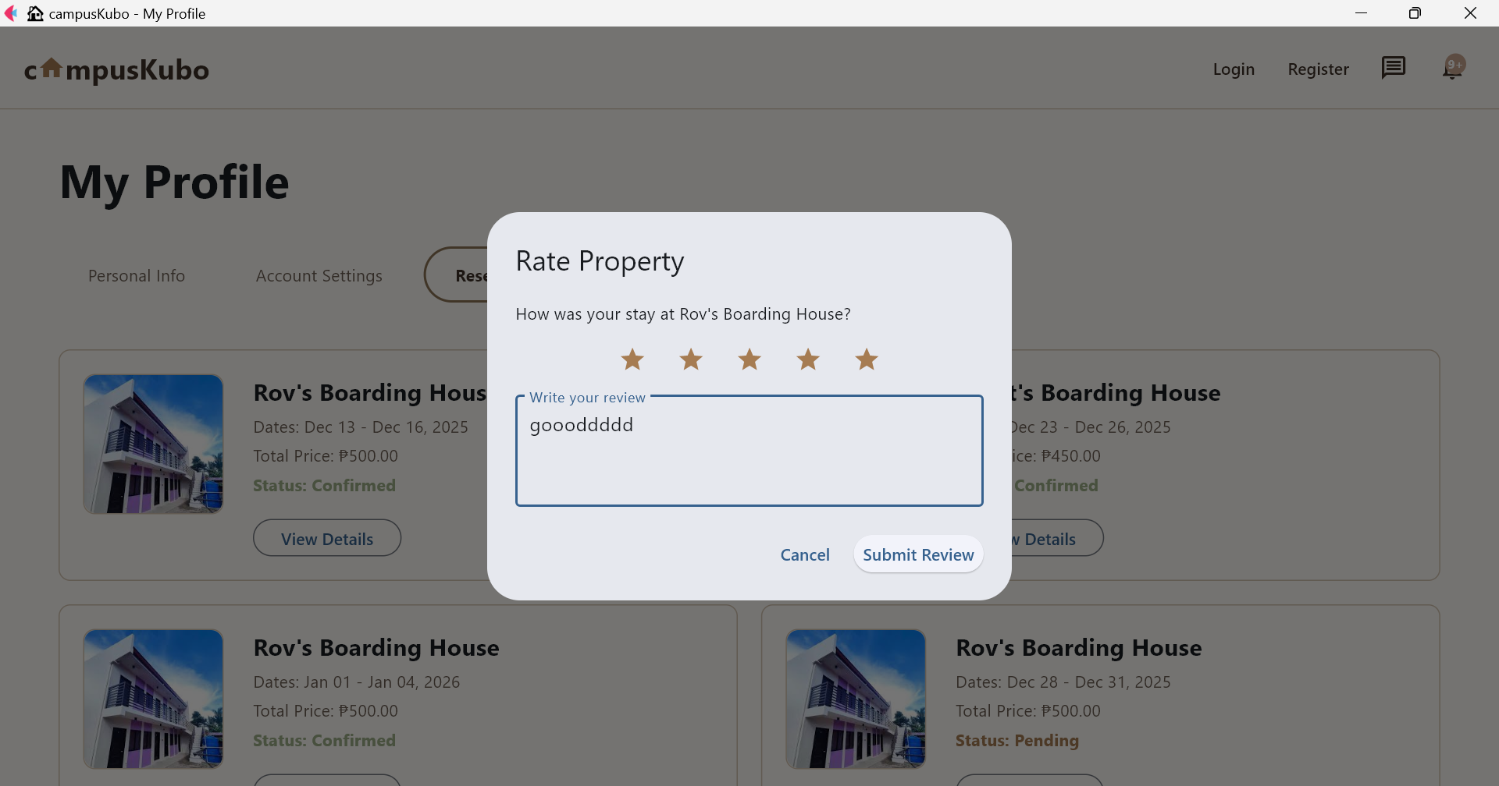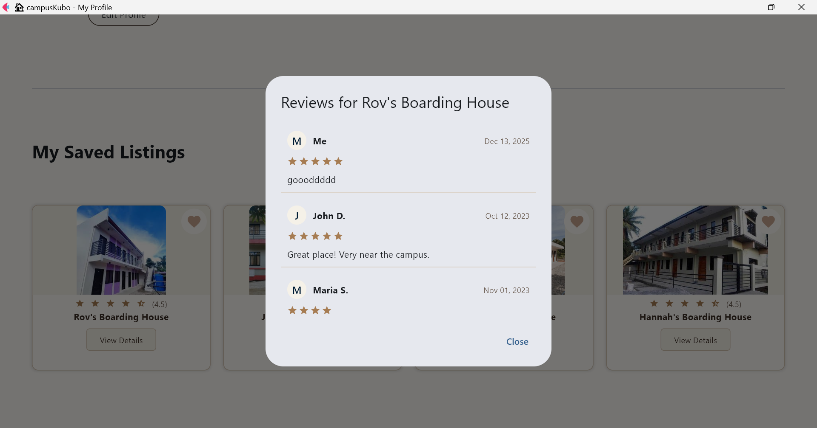
Users can rate a property by giving stars and writing a review, and they can also view all reviews with ratings, names, and comments.

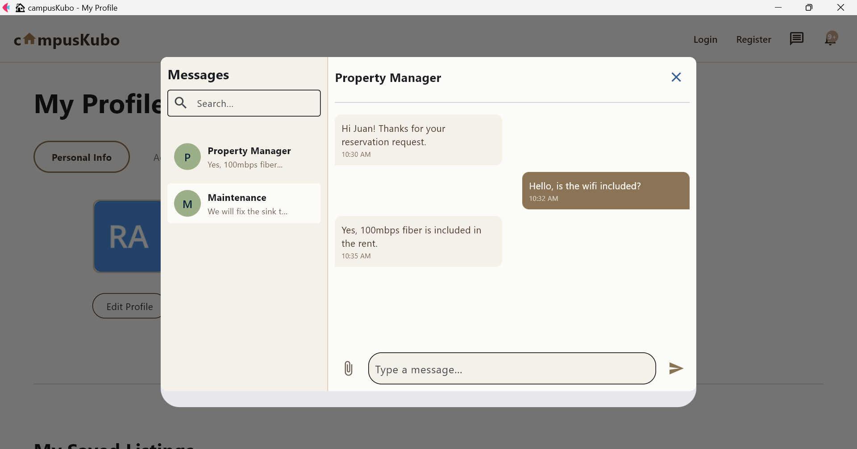
Shows conversation between tenant and property manager about amenities.

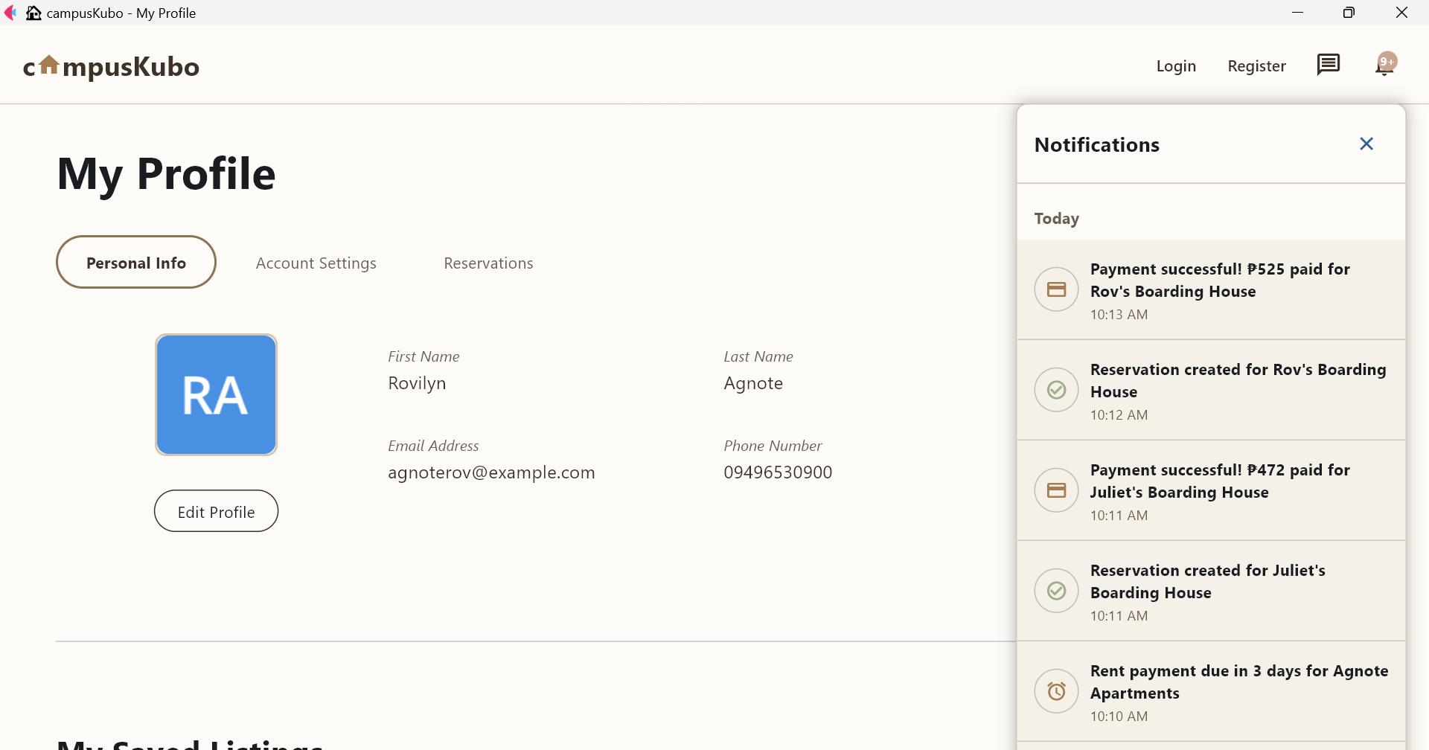
Lists recent activity like payments, reservations, and rent reminders.

- Troubleshooting

- Common Issues

- Application won't start
  - Check Python version (3.8+)
  - Verify all dependencies are installed
  - Check database file exists

- Login issues
  - Verify email and password
  - Check account is active

- Upload failures
  - Check file size limits
  - Verify supported file types
  - Check upload directory permissions

- Payment issues
  - Verify payment method details
  - Check internet connection
  - Contact support for failed transactions

- Support

For technical support, contact:
- Documentation: Check the technical documentation
- GitHub Issues: Report bugs on the repository

